**THREE STEP AUTHENTICATION**

**A major project report submitted in partial fulfillment of the requirements for the award of the degree of**

BACHELOR OF TECHNOLOGY

IN

COMPUTER SCIENCE AND ENGINEERING

Submitted by

**RAKAM ARAVIND, 121710317045**

**PUTCHA VAISHNAVI, 121710317044**

**CH V AARATHI, 121710317010**

**S VARAHA RAKESH, 121710317051**

Under the esteemed guidance of

**Mr. A. Yashwanth**

**Asst. Professor, CSE, GITAM**



**DEPARTMENT OF COMPUTER SCIENCE AND ENGINEERING**

**GITAM**

**(Deemed to be University)**

**VISAKHAPATNAM**

**May 2021**

**DEPARTMENT OF COMPUTER SCIENCE AND ENGINEERING**

**GITAM INSTITUTE OF TECHNOLOGY**

**GITAM**

**(Deemed to be University)**



**CERTIFICATE**

This is to certify that the project report entitled “**THREE STEP AUTHENTICATION**” is the bonafide record of work by **Mr. Rakam Aravind (121710317045), Miss. Putcha Vaishnavi (121710317044), Miss. CH V Aarathi (121710317010), Mr. S Varaha Rakesh (121710317051)** students submitted in partial fulfillment of requirement for the award of degree of Bachelors of Technology in Computer Science and Engineering.

**Project Guide**  **Head of the Department**

**Mr. A. Yashwanth Dr. R. Sireesha**

**Asst. Professor Professor**

**DEPARTMENT OF COMPUTER SCIENCE AND ENGINEERING**

**GITAM INSTITUTE OF TECHNOLOGY**

**GITAM**

**(Deemed to be university)**



**DECLARATION**

We, hereby declare that the main project report entitled “**THREE STEP AUTHENTICATION**” is an original work done under the guidance of **Mr. A. Yaswanth**. A main project report submitted in partial fulfillment of the requirements for the award of the degree of bachelor of technology in computer science and engineering, GITAM (Deemed to be University), Visakhapatnam. The work has not been submitted to any other college or university for the award of any degree or diploma.

Date:

**Registration No.(s) Name(s) Signature(s)**

121710317045 Rakam Aravind

121710317044 Putcha Vaishnavi

121710317010 Ch V Aarathi

121710317051 S Varaha Rakesh

**ACKNOWLEDGEMENT**

I wish to thank **Dr. R. Sireesha**, HOD, Dept. of CSE, and also our University Management who gave us an opportunity to improve our knowledge base by encouraging us to perform a mini project to gain experience.

I would like to thank my professor **Mr. Yaswanth Amanapu** who motivated us to work on this project, Cyber Security course has given me the platform to hone and take the initiatives to learn and provided me with online training and various other online resources that I referred to during this course. I want to thank each one of them for their pa, and for the time that they devoted to developing the course.

The faculty and the guides at Gitam University contributed so much throughout the project. So I wish to thank Gitam University and the guides **Mr. Yaswanth Amanapu** for everything. Thanks to everyone who has contributed either directly or indirectly in this internship.

I perceive this learning opportunity as a big milestone in my career development. I will strive to use gained skills and knowledge in the best possible way, and I will continue to work on their improvement, in order to attain desired career objectives.

We express our sincere thanks to Shri. A. Yashwanth, our AMC and reviewers Shri. S.V.G. Reddy and Shri. V. Praneel who helped and supported us a lot in the successful completion of our project.

Sincerely,

**Rakam Aravind, 121710317045**

**Putcha Vaishnavi, 121710317044**

**Ch V Aarathi, 121710317010**

**S Varaha Rakesh, 121710317051**

**ABSTRACT**

Cyber Security plays an important role in the field of information technology. Securing the information have become one of the biggest challenges in the present day. Whenever we think about the cyber security the first thing that comes to our mind is ‘cyber crimes’ which are increasing immensely day by day. Various Governments and companies are taking many measures in order to prevent these cybercrimes. Besides various measures cyber security is still a very big concern to many. This paper mainly focuses on challenges faced by cyber security on the latest technologies. It also focuses on latest about the cyber security techniques, ethics and the trends changing the face of cyber security. With the advancement of technology, it has become inevitable to raise the security levels. Our project is about the secure payments using three step authentication process, in order to do payments in more secure manner. The first step of authentication is entering the username and the password. The second step of authentication is One Time Password (OTP) received in mobile and the OTP is authenticated. As part of the third step user’s fingerprint is taken to recognize the user’s identity before proceeding with the payment, after the OTP is verified based on the random 5-digit number generated by 2Factor (a website used to generate OTP) fingerprint is taken. With regards to the fingerprint, upon OTP validation the user is redirected to another page where user must enter email id to receive the link which redirects to the application on the user’s mobile, using that link finger print authentication is taken. Only on giving the correct fingerprint with the correct finger the payment will be processed. In this documentation how each and every step is executed will be discussed briefly.

**TABLE OF CONTENTS**

|  |  |  |
| --- | --- | --- |
| **S.NO** | **TITLE** | **Page no** |
| 1. | Abstract | 5 |
| 2. | Introduction | 7 |
| 2.1. | What is single-step authentication? | 7 |
| 2.2. | What is two-factor authentication? | 7 |
| 2.3. | What is multi-factor authentication? | 7 |
| 3. | Why the third step and how is it useful in our project? | 7 |
| 4. | Types of validation | 8 |
| 5. | Login Authentication(1st step) | 8 - 10 |
| 6. | One-Time-Password (OTP)(2nd Step) | 11 - 16 |
| 7. | Biometric (3rd Step) | 17 - 21 |
| 8. | Codes and Result | 22 - 56 |
| 9. | Conclusion | 57 |
| 10. | References | 58 |

**INTRODUCTION**

**PROJECT SOFTWARE REQUIREMENTS**

1.PHP Server (Xampp)

2.Database

3.SMTP Server

4.OTP Sender (3rd party application)

5.Android Studio

6.Sublime Editor

**2.1. What is single-step-authentication?**

Single-factor authentication is the simplest form of authentication methods. With SFA, a person matches one credential to verify himself or herself online. The most popular example of this would be a password (credential) to a username. Most verification today uses this type of authentication method.

**2.2. What is two-factor authentication?**

Two-factor authentication uses the same password/username combination, but with the addition of being asked to verify who a person is by using only he or she owns, such as a mobile device. Putting it simply: it uses two factors to confirm an identity.

**2.3. What is multi-factor authentication?**

Multi-factor authentication uses a combination of the following factors: something you know, something you have, and something you are. 2FA is a subset of MFA.

**Why the third step and how is it useful in our project?**

The first two steps of authentication are common in multi-factor authentication, but why we need the next step after the two steps is, after entering the login credentials in the first place and thereafter the user must enter the One-Time-Password (OTP) which is sent through Short-Message-Service (SMS), but still, the user’s confidentiality has no assurance, because, the third- party users or hackers exploit the user’s confidentiality and hence the third step is introduced to provide the user with more confidentiality and integrity.

Hence our project is to develop an application that provides users with more safety and security by taking what the user knows, has, and is i.e. the user’s fingerprint. As part of the third step user’s fingerprint is taken to recognize the user’s identity before proceeding with the payment.

Based on the random 5-digit number generated by 2Factor (a website used to generate OTP) on giving the desired phone number the fingerprint is taken. Only on giving the correct fingerprint with the correct finger (each finger is numbered and based on that number that respective finger must be taken), the payment is processed.

**Types of validation in the project**

1. Login authentication (username and password)

2. OTP generation and validation (through sms)

3. Biometric validation

**Login Authentication (1st step):**

The first step of authentication is entering the username and the password.

**Sql login authentication and its injection vulnerabilities**

If we store the information in database and use sql to retrieve the data and check it.

There is a high possibility of sql Injection vulnerabilities where even without username and password one can login in to the page.

So it is not highly advisable to use sql database. If used so there should be CIA triad involved in that.

**JS LOGIN AUTHENTICATION**

In this the username and the passwords are given. The JavaScript file authenticates the valid username and password and gives access to the user.

Unlike html the JavaScript file cannot be inspected on the browser.

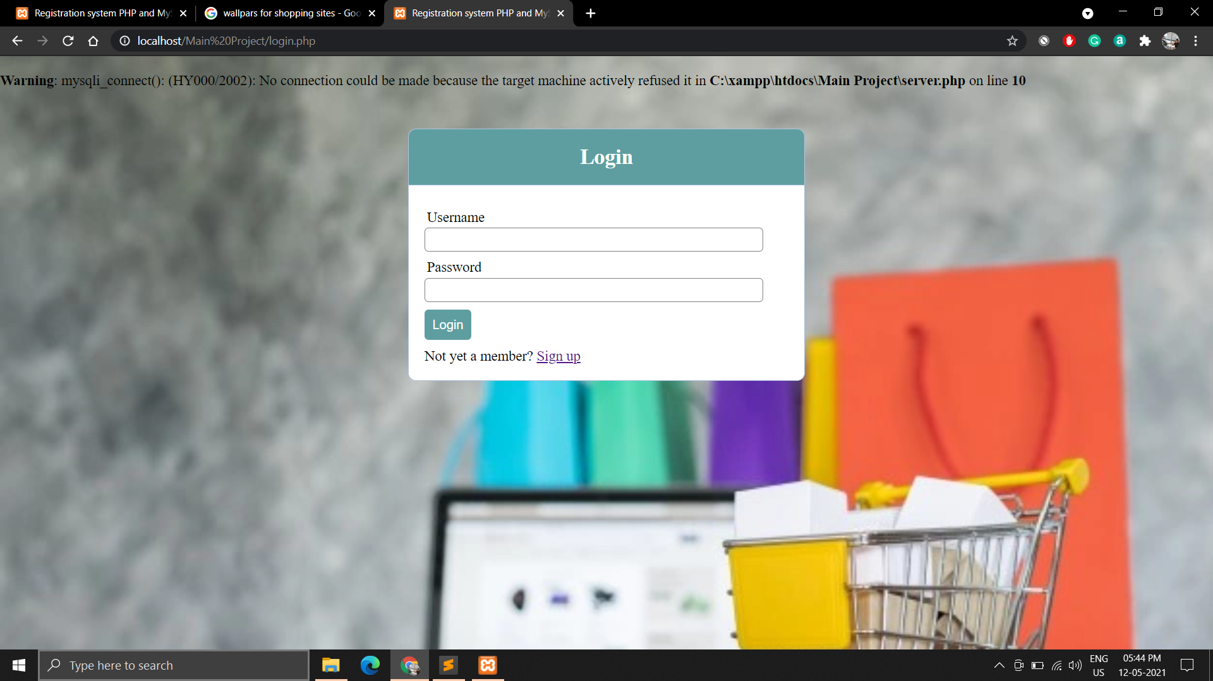

Register Page:

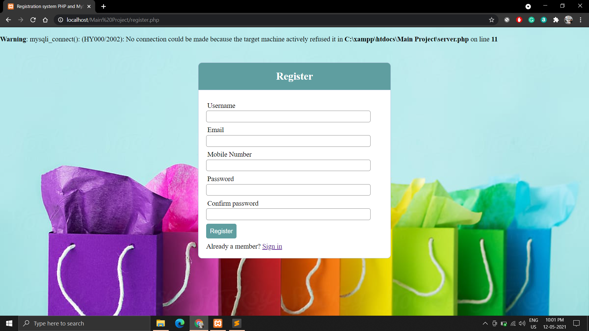

**SHOPPING CART**

After successful login authentication you will be redirected to the shopping cart. There you can choose the products present in it and then you can check out.

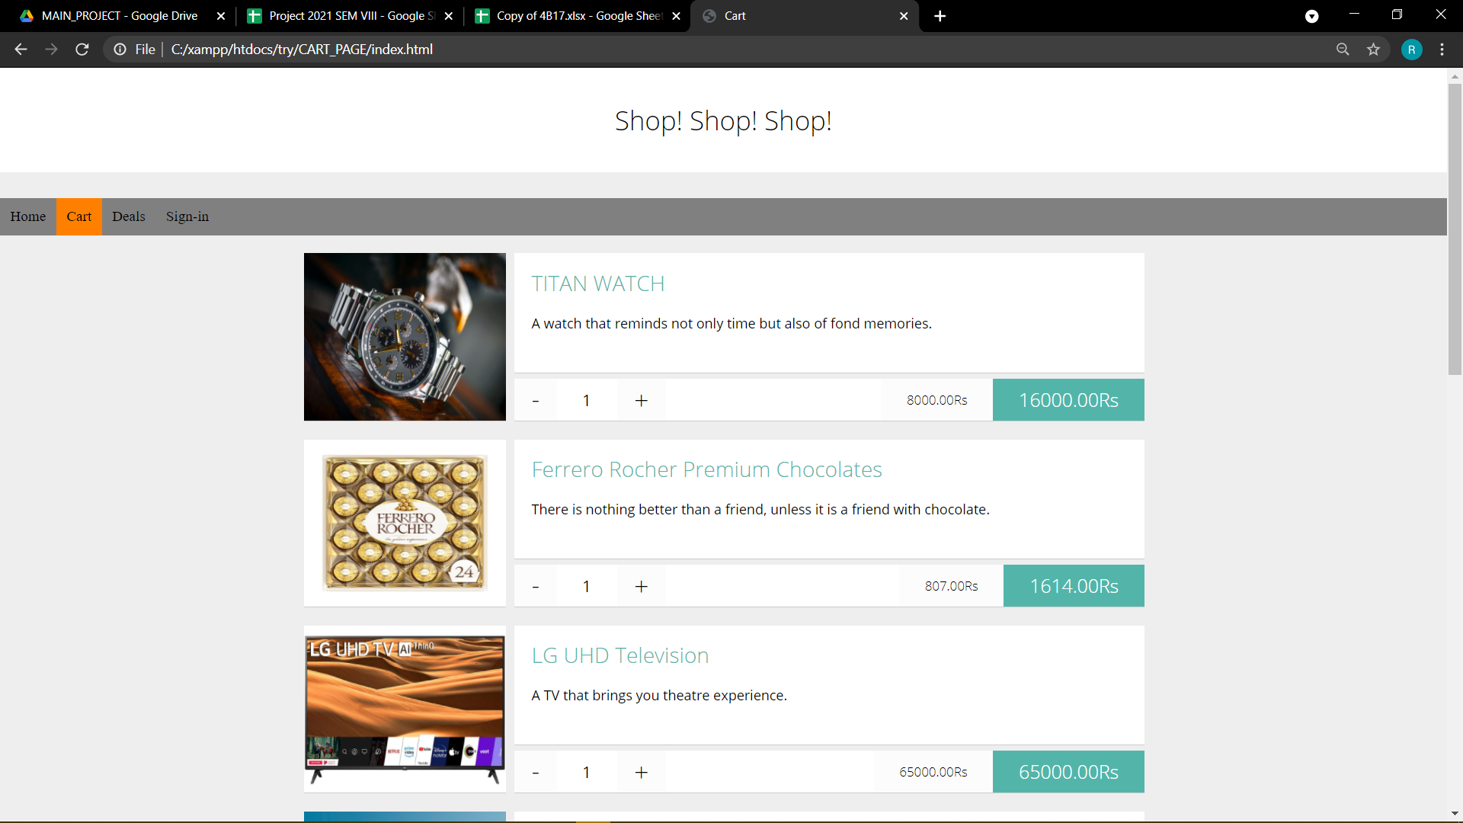

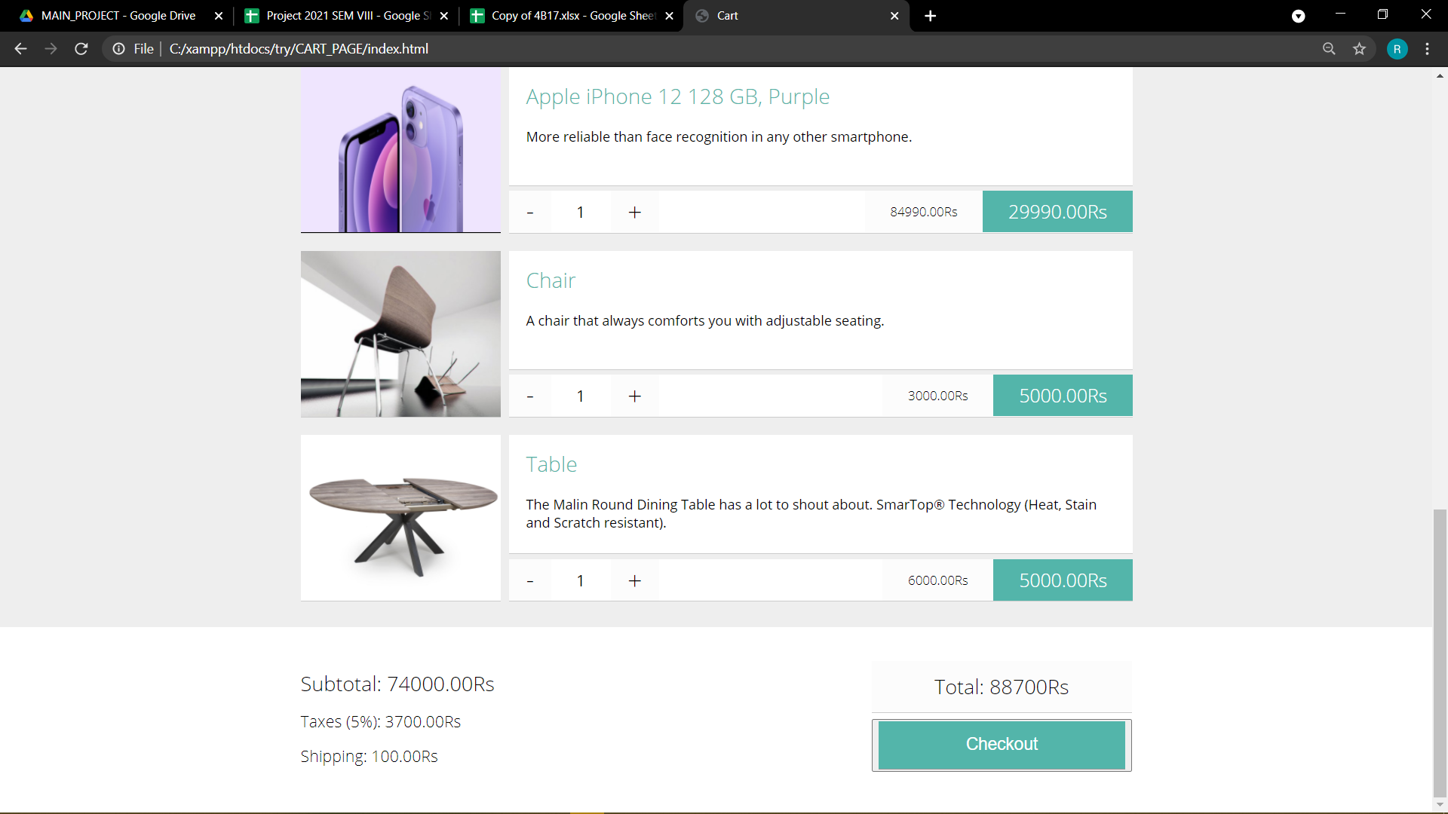

**Payment page**

After Clicking on Checkout you will be redirected to payment page

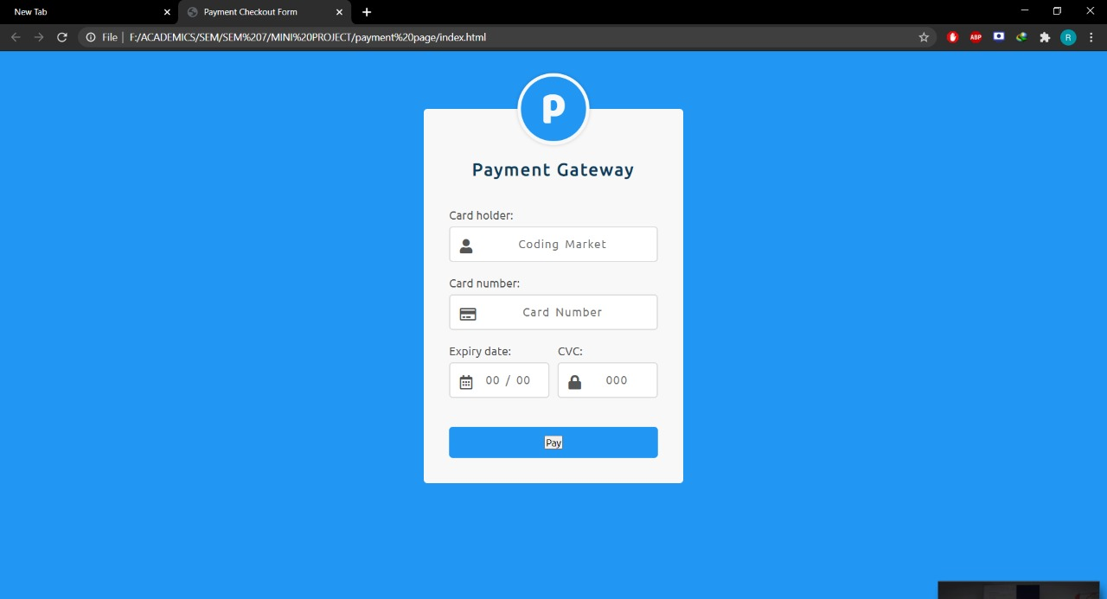

**One-Time-Password (OTP) (2nd Step):**

* **Via SMS:**

A one-time password (OTP), also known as one-time PIN or dynamic password, is a password that is valid for only one login session or transaction, on a computer system or other digital device.

An **SMS OTP** (one-time password) is a secure authorization method where a numeric or alphanumeric code is sent to a mobile number. This password is an added layer of security used to verify the identity of a user logging into an online platform, application or website.

For User: To receive an **OTP by SMS**, you have to enable two-factor authentication and request a one-time password from the application or website you want access to by entering your registered mobile number and clicking on “Send **OTP**”. You will receive an **OTP** within seconds on your **SMS** inbox.

On submitting the registration form an Email/SMS with **OTP** is sent to the email address/mobile **number** provided by the user. Once the **OTP** is entered, then it is verified by our servers and the user gets registered. If you are looking for Authentication of users during Login then we have a separate module for this.

**Introduction**. Traditionally, two-factor **authentication** uses a one-time password (OTP), which combines something the user knows (a username and password) and something the user has (typically, a token or key fob that produces a six-digit number, valid only for a short period of time and available on demand).

User **can bypass** the **OTP** verification needed while placing an order with a restaurant. User **can** give a random number and intercept the **OTP** request. If wrong **OTP** is provided then the error message shows the session code which is the **OTP** in this case.

* **Via Email:**

The Email OTP method enables you to authenticate using the one-time password (OTP) that is sent to the registered email address. When you try to authenticate on any device, the server sends an email to the registered email address with the OTP. You can use this OTP for single authentication within a short time frame.

This authenticator is enrolled automatically and you cannot remove it.

1. Click the Email OTP  icon in Add Authenticator.
2. (Optional) Specify a comment related to Email OTP authenticator in Comment.
3. (Optional) Select the preferred category from Category.
4. Specify the email address in Email.
5. Click save.
6. A message Authenticator "Email OTP" has been added is displayed.

**Pros and cons of one-time passwords**

**Pros**

Is safe from replay attacks

The biggest advantage offered by OTPs in contrast to standalone passwords is that they’re safe from replay attacks. In plain language, an adversary who uses trickery to capture your OTP can’t reapply it, since it’s no longer valid for future logins or sessions.

* Allows you to keep your emails safe

OTPs are generally received on mobile devices via SMS. This means you don’t need to have access to your email. Hence, you can avoid logging into your email account on public computers or while you’re connected to an unsecured Wi-Fi hotspot.

* Is convenient to use

Most individuals own a mobile phone, and SMS functionality exists on every device. SMS’s ubiquity means that one-time passwords are convenient to use. This is also beneficial for businesses that deliver the OTPs, as end users are already familiar with their phones and don’t need another device to receive the code. As a result, OTPs allow companies to not only enhance the user experience but also reduce their operational costs.

**Cons**

* Could get out of sync

Electronic codes have their fair share of problems. Algorithm-based OTPs need to cope with drifting out of sync with the authentication server if the system needs the OTP to be submitted by a deadline. Fortunately, the problem can be easily avoided by using a time-synchronized system. These systems prevent such issues by maintaining a time clock in electronic codes.

* Can lock you out of your account

If your OTP device is ever stolen or lost, multiple login attacks by the hacker can permanently lock you out of your account. This can be a hassle when you’re traveling, as getting in touch with the OTP provider may require an international call, incurring expensive roaming charges. And if the provider doesn’t limit the number of login attempts, the adversary may still be able to hack your account through brute force.

* May be costly for the providers

For OTP providers, costs can be a problem, especially if they’re offering OTP hardware. Other issues with hardware devices are that they can be stolen, damaged or lost. Moreover, users will need to go through the hassle of charging when battery life comes to an end. The best way to avoid these problems is to deliver one-time passwords via SMS messaging.

* The risk of receiving an OTP via SMS is that an attacker could call the phone company and have the number the SMS will be sent to redirected to a phone the attacker controls. This assumes the attacker knows the phone number and provider of the victim's cell phone. This risk is difficult to mitigate as the sender of the OTP will not be informed about the phone change, and the victim may not be aware of the phone change immediately.
* The risk of receiving an OTP via email is that the attacker may have access to the victim's email. Assuming the email account is well-protected and secure (stated in the question) will mitigate this risk.

**DECISION MADE ON OTP**

It is suggestable to keep getting OTP via your mobile phone as it is easy for your email to get hacked and it is tough to tap on your mobile phone SMS. Protect your mobile from installing apps from trusted resource and never give your mobile to anyone moreover if the SMS is not secure banks won't be using them till now. So even in our project we used SMS which provides the timeout service and also the user can use resend option.

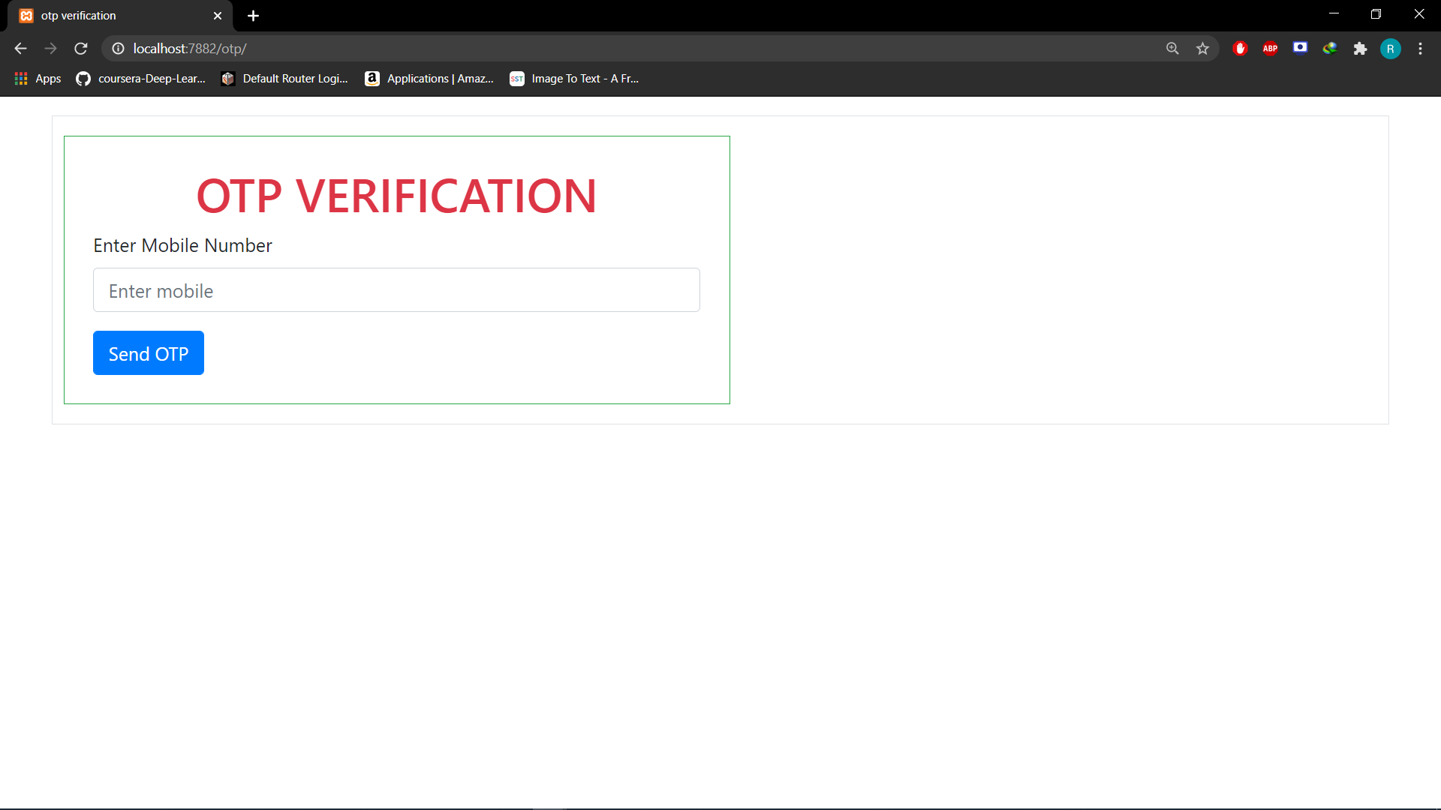

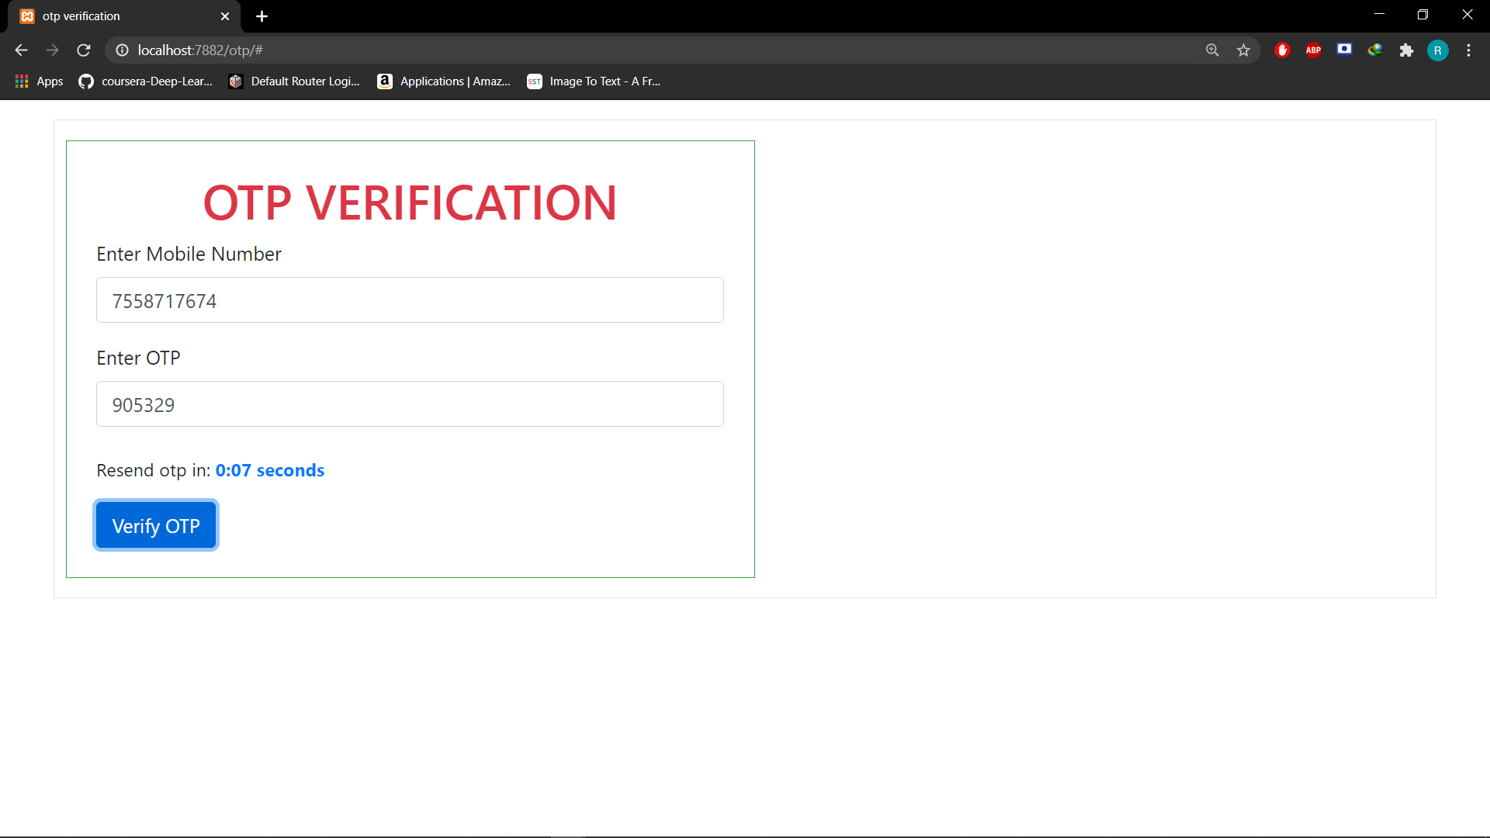

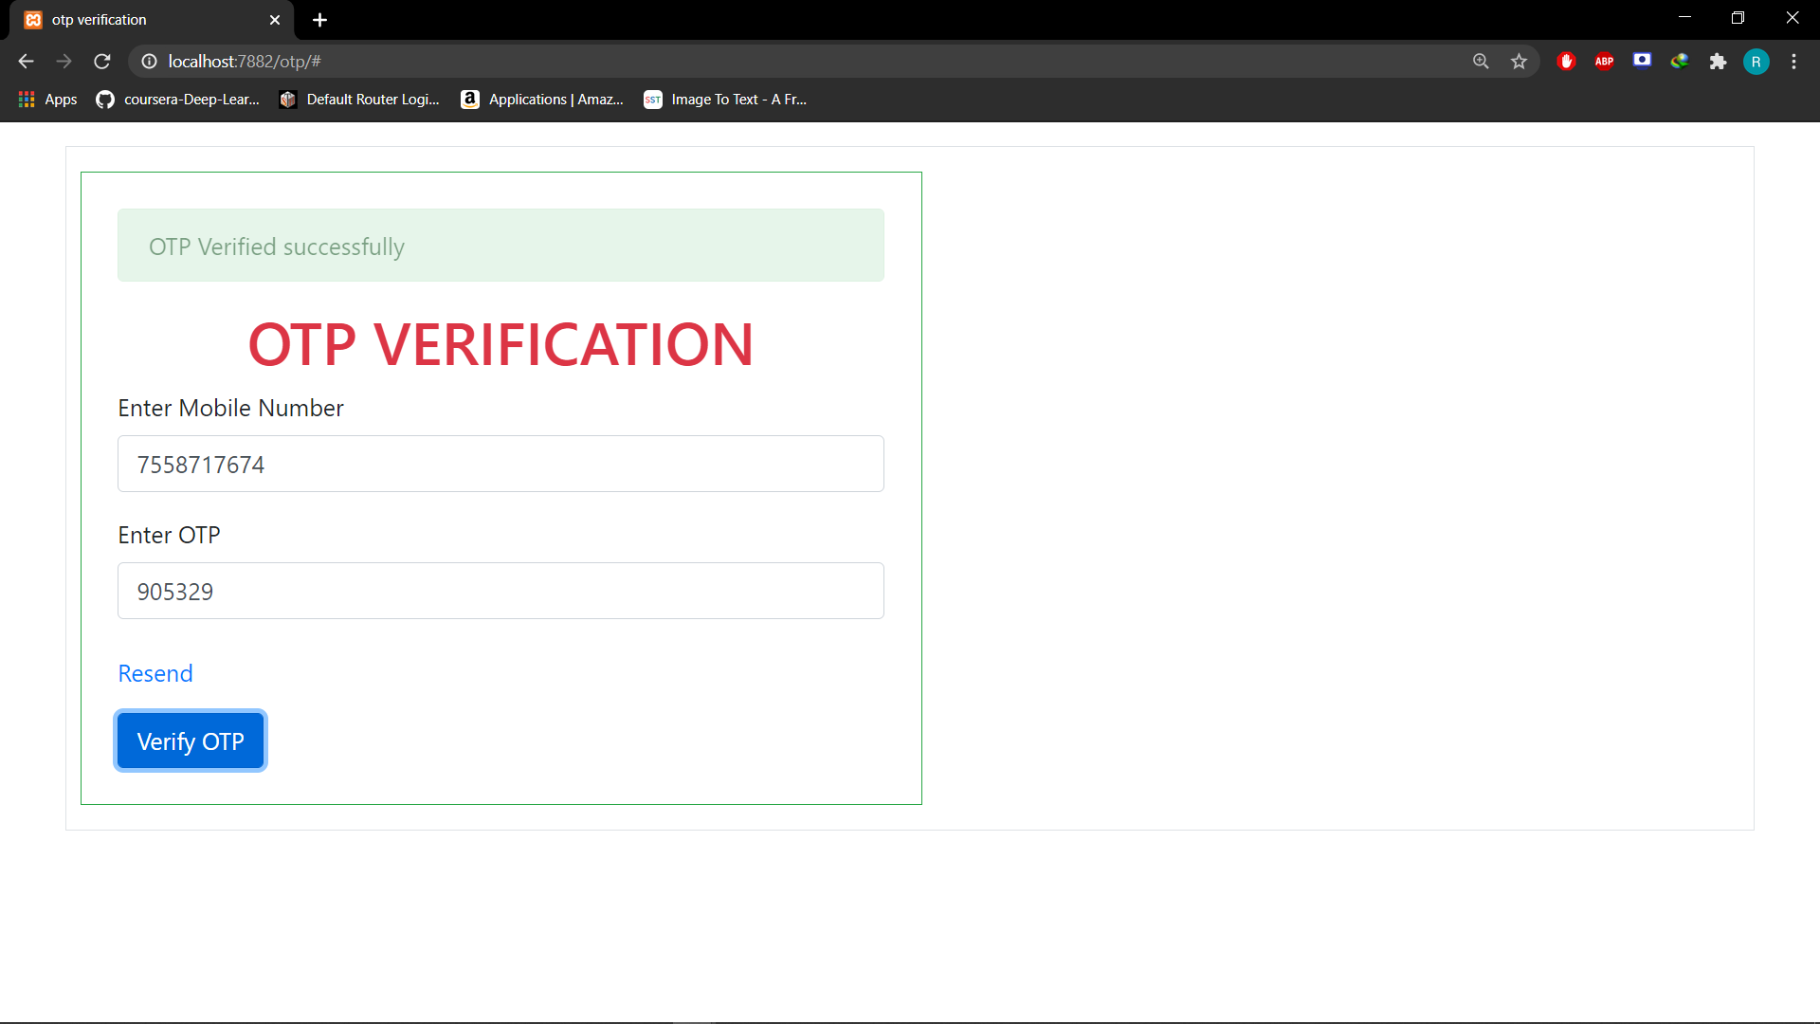

**Biometric (3rd Step)**

* Types of Biometry
* Why we choose fingerprint over the others
* Different biometric algorithms
* Best amongst those

**Types of biometrics**

* Ear: The identification of an individual using the shape of the ear.
* Eyes – Iris Recognition: The use of the features found in the iris to identify an individual.
* Eyes – Retina Recognition: The use of patterns of veins in the back of the eye to accomplish recognition.
* Face Recognition: The analysis of facial features or patterns for the authentication or recognition of an individual’s identity. Most face recognition systems either use Eigen faces or local feature analysis.
* Fingerprint Recognition: The use of the ridges and valleys (minutiae) found on the surface tips of a human finger to identify an individual.
* Finger Geometry Recognition: The use of 3D geometry of the finger to determine identity.
* Voice - Speaker Identification: Identification is the task of determining an unknown speaker’s identity. Speaker identification is a 1: N (many) match where the voice is compared against N templates. Speaker identification systems can also be implemented covertly without the user’s knowledge to identify talkers in a discussion, alert automated systems of speaker changes, check if a user is already enrolled in a system, etc. For example, a police officer compares a sketch of an assailant against a database of previously documented criminals to find the closest match(es). In forensic applications, it is common to first perform a speaker identification process to create a list of “best matches” and then perform a series of verification processes to determine a conclusive match.

**Why fingerprint?**

* A biometric is a unique biological characteristic which can be used to identify and verify a person’s identity. Apart from fingerprints, we see this in facial recognition scans, DNA tests, and less commonly in palm prints, and iris and retina recognition.
* Biometrics are marketed as being a very secure solution, because the way biometric data is stored is different to the ways PINs and passwords are stored.
* While passwords are stored on [the cloud](https://home.bt.com/tech-gadgets/computing/cloud-computing/eight-things-you-need-to-know-about-the-cloud-11363891172534), data from your fingerprint is stored solely on your device. Servers and apps never have access to your fingerprint data, nor is it saved on the cloud.
* However, although it’s incredibly hard for cybercriminals to get access to your actual fingerprint data – since it’s encrypted and stored on the device itself – biometric systems are still not completely secure.
* For instance, Apple’s fingerprint technology was compromised [just two days after the launch of Touch ID](https://www.theguardian.com/technology/2013/sep/22/apple-iphone-fingerprint-scanner-hacked) (integrated into the iPhone 5S) in 2013. And since then, many people have managed to bypass Touch ID security by [using dental mold or play-dough](https://www.theverge.com/2016/5/2/11540962/iphone-samsung-fingerprint-duplicate-hack-security).
* Similarly, it was shown that even the 2017 iPhone X’s [Face ID](https://support.apple.com/en-au/HT208109) feature [could be compromised](https://www.wired.com/story/hackers-say-broke-face-id-security/).
* Users who use Touch ID with a four-digit PIN backup are also at risk. They’re susceptible to “shoulder surfing” attacks, where attackers simply look over a victim’s shoulder to see them input their PIN.
* Other types of attacks include password guessing and even thermal fingerprint scanning, which involves using a thermal device to figure out which areas on a screen were most recently pressed, thereby potentially revealing a passcode combination.

**Biometric algorithms**

* Biometric algorithms are automated methods that enable a biometric system to recognize an individual by his or her anatomical/behavioural traits. They consist of a sequence of automated operations performed by the system to verify or identify its ownership. These operations include quality assessment, enhancement, feature extraction, classification/indexing, matching and fusion, as well as compression algorithms, often used to reduce storage space and bandwidth.

**The idea is to make use of mobile fingerprint scanner as biometric scanner**

* Not all android phones can perform biometric scans to register or identify someone. This is mostly because of lack of permission provided by the Android operating system and lack of compatibility between different biometric sensors used by different manufacturers and your matching engine’s quality requirement. Besides, regular fingerprint sensor found in today’s smartphones are only good for unlocking your phone. However, to perform sophisticated biometric registration and to identify someone’s identity from your database, you will need a particular android phone with a high-quality biometric scanner that can save biometric data according to the requirement of your matching engine.
* M2SYS have 3 android phones and 1 tablet that is perfect for any biometric identification or enrollment project.

**Security reasons involved**

* For security purposes this will never be allowed as explained by other members here. The device should not have any storage so they can't store any information. This is why only certified devices are allowed.
* Now for personal authentication purposes aadhaar may release an app that can use the phone's fingerprint scanner. I am assuming it will be like a bank app where the registered number has to be in use on the phone.
* This will enable only the user to verify his eKYC remotely for online websites.
* No the fingerprint scanner can never be used as an ekyc scanner as some people are suggesting. That is, it can never replace the eKYC fingerprint scanner for companies

**Process of biometric authentication**

* After you have successfully verified your One Time Password (OTP)

you will be asked to enter your registered email id.

* After you have entered your registered email id it will check with registered email id
* If it matches with registered email id, then an email will be sent to your email id which android biometric authentication app link will be present.

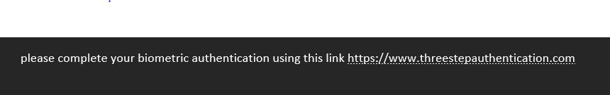

* By clicking on that link you will be redirected to the installed Finger print authentication app.
* Place your registered thumb on the fingerprint sensor of the mobile.
* If your biometric authentication is successful, then your payment will be successful if not it will not be successful.

**WHEN YOU OPEN THE APP**

When you place your registered fingerprint the third step is successful, and then payment is made.

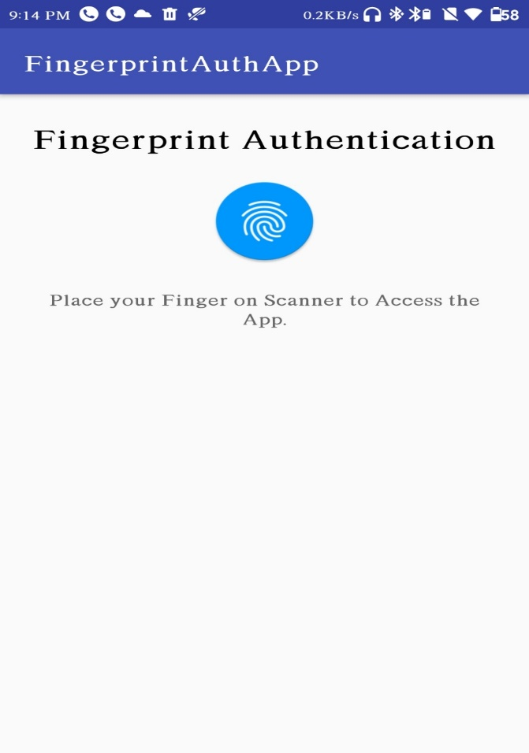 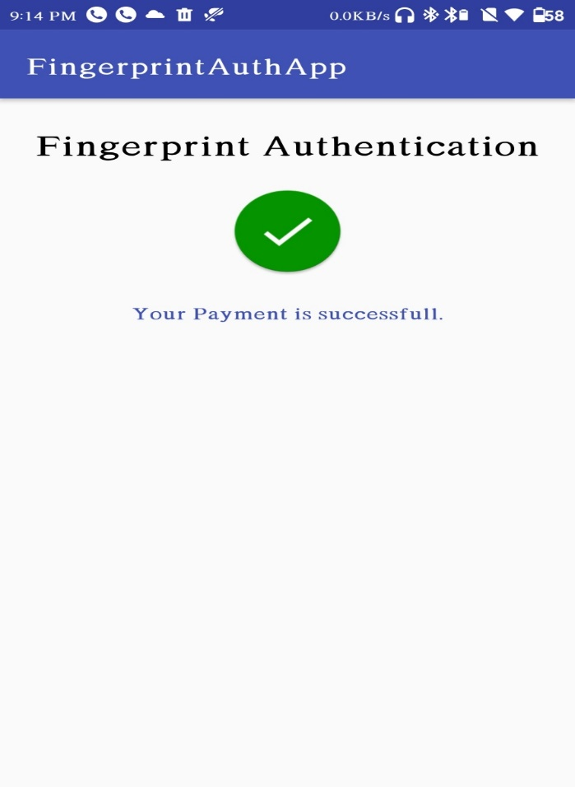

**CODES and RESULT**

**Code: (index.php)**

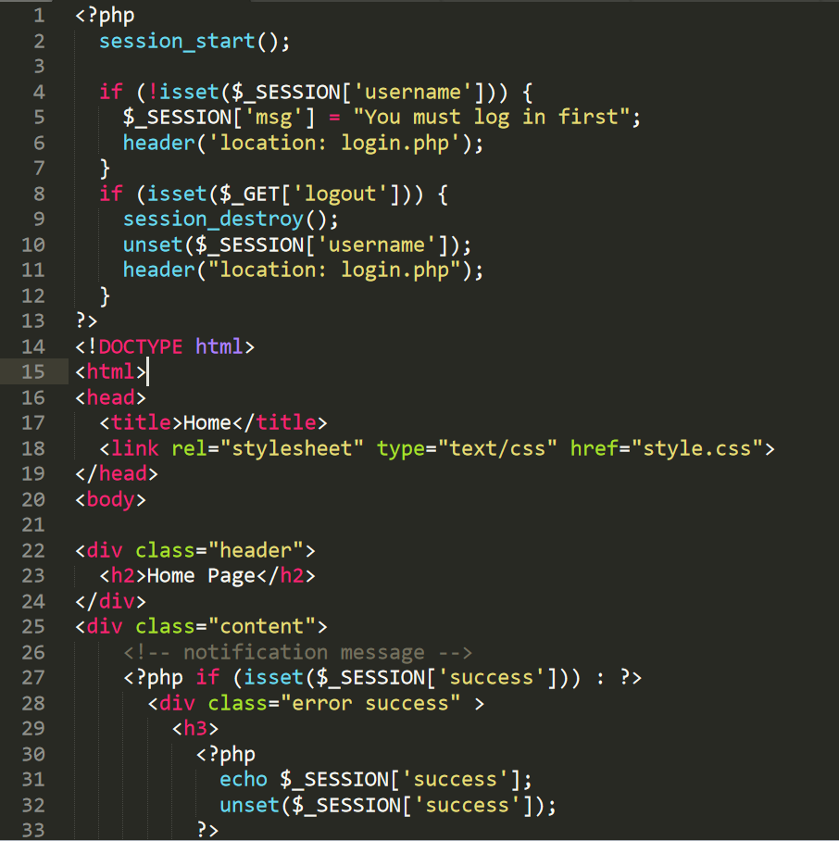



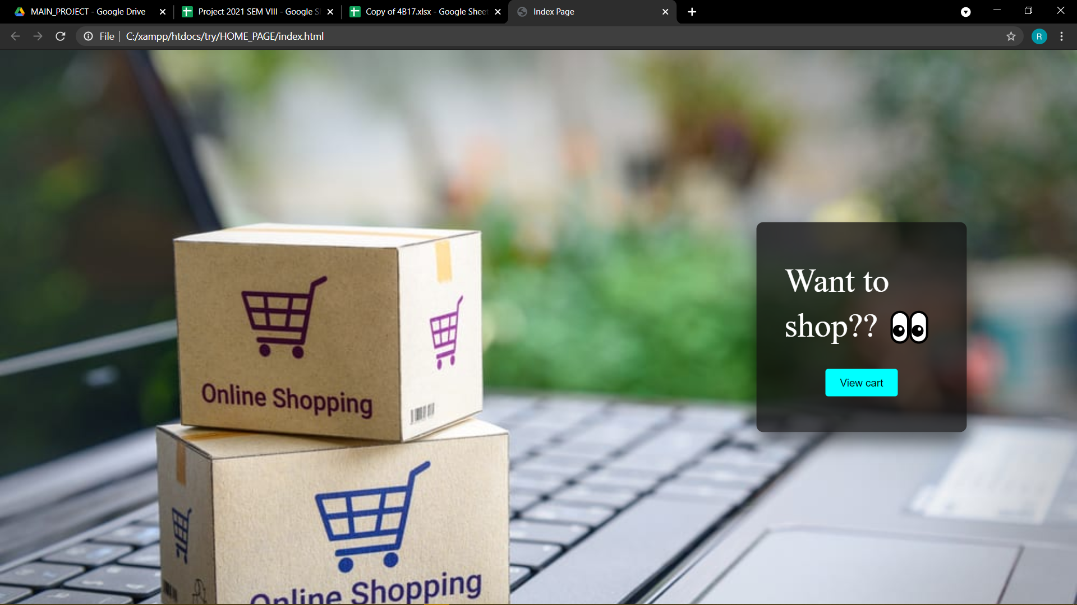

**LOGIN PAGE (login.php)**

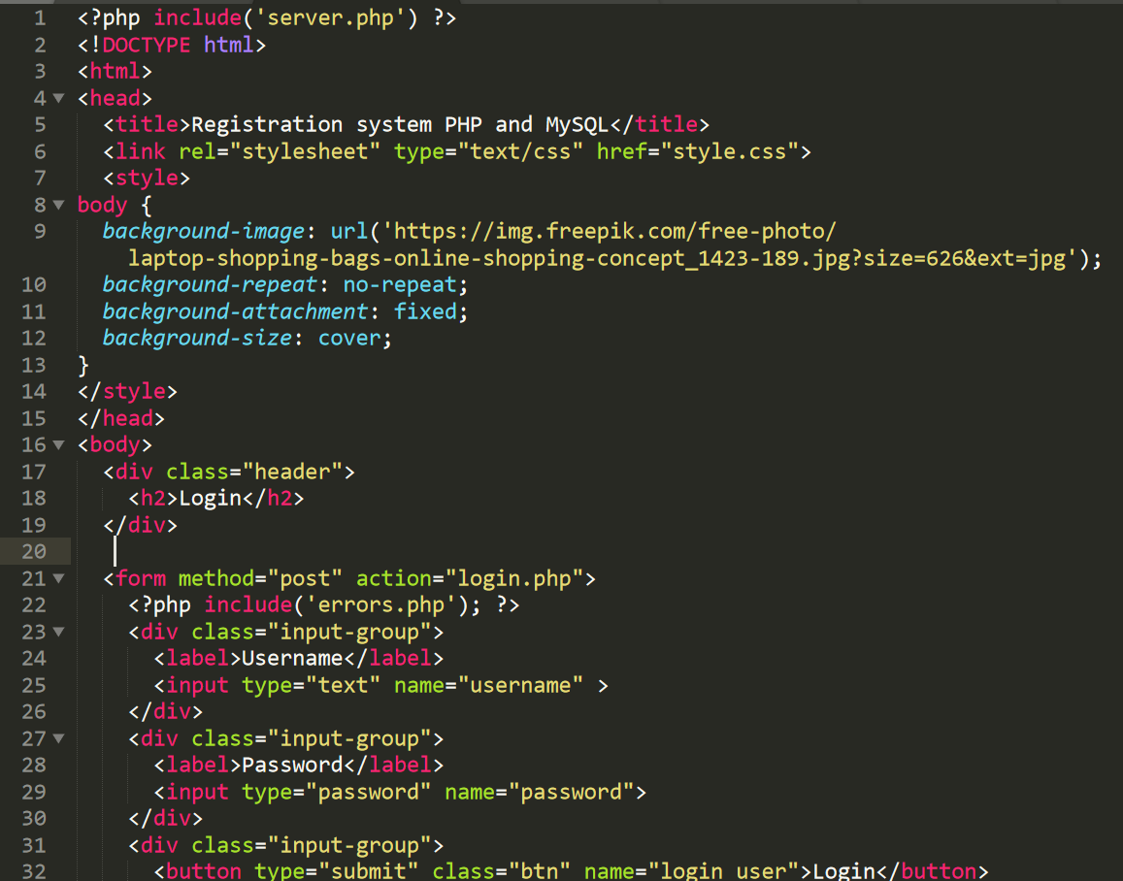

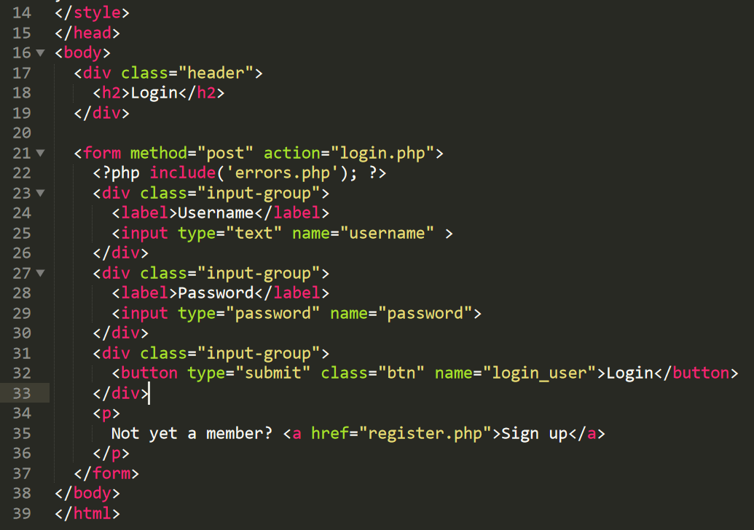



**Registration Page (register.php)**

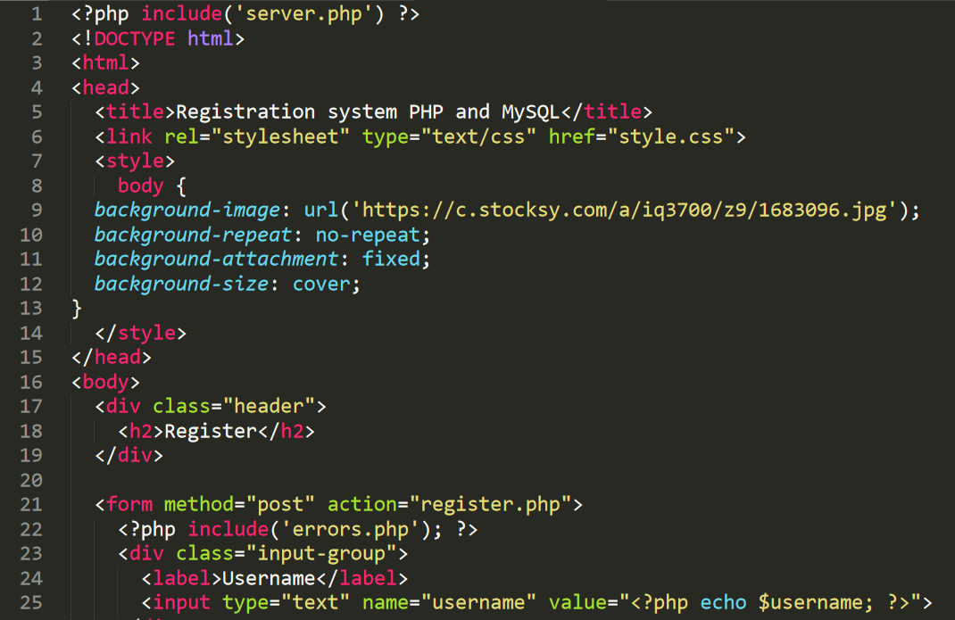

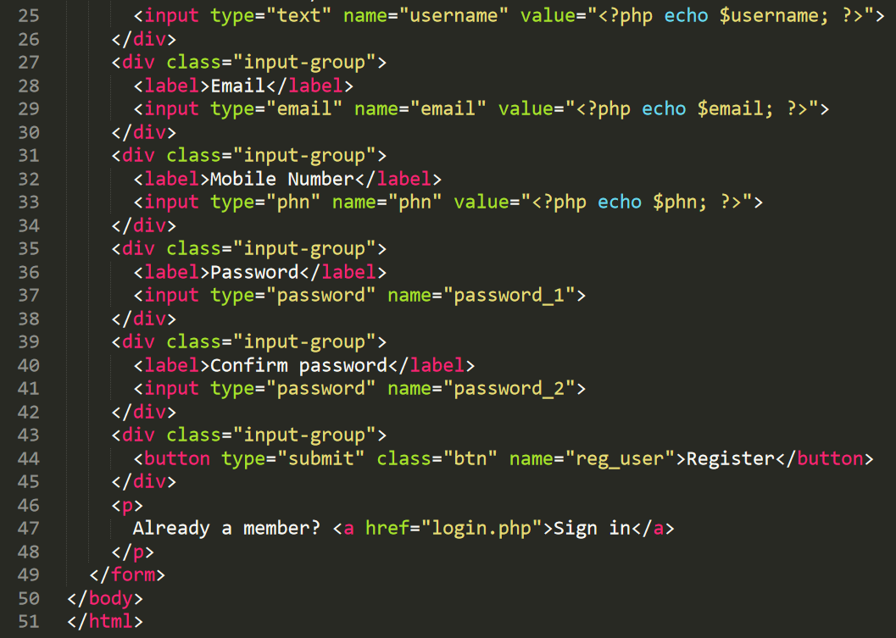



**SHOPPING CART**

**(cart_page)**

**Code: (index.html)**

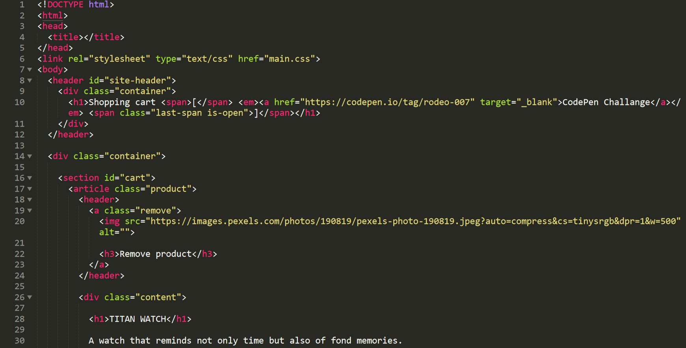



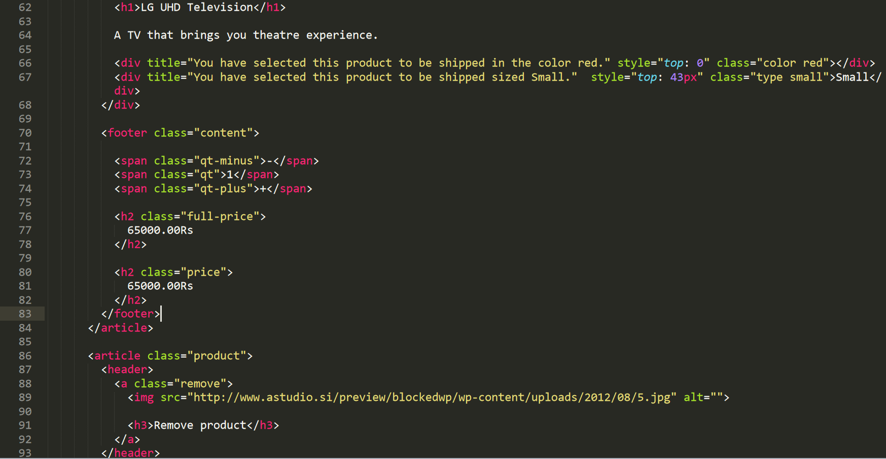



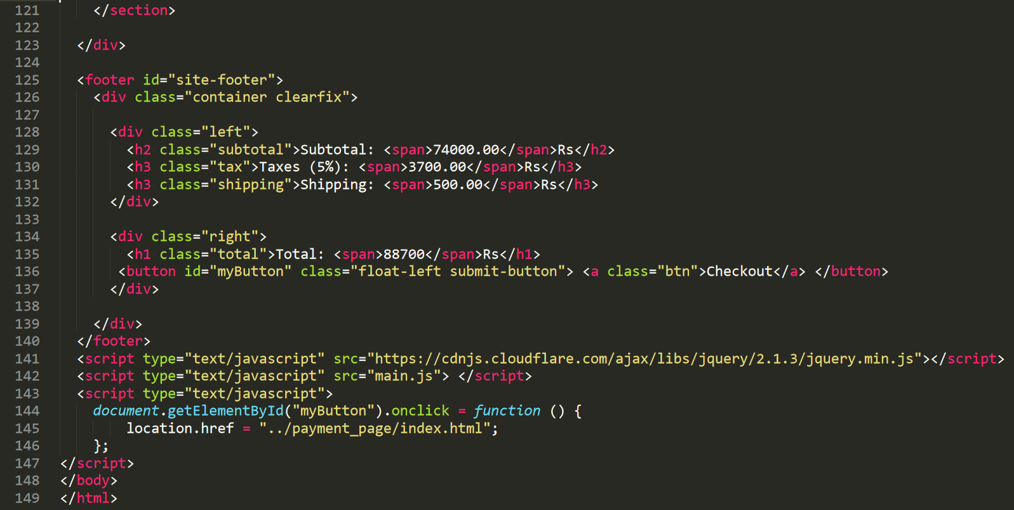

**Code: (main.js)**

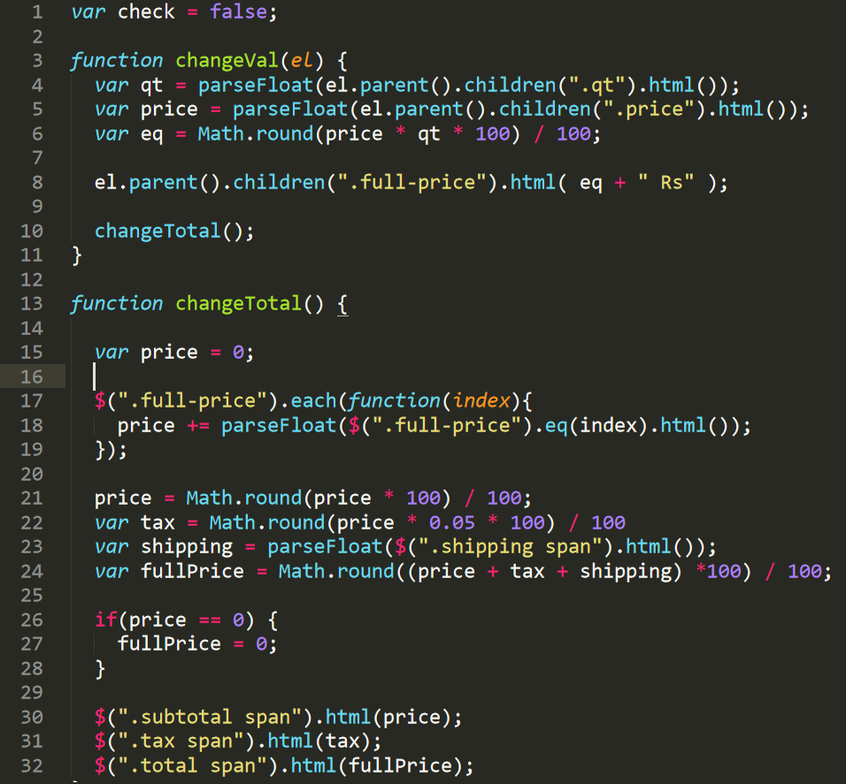

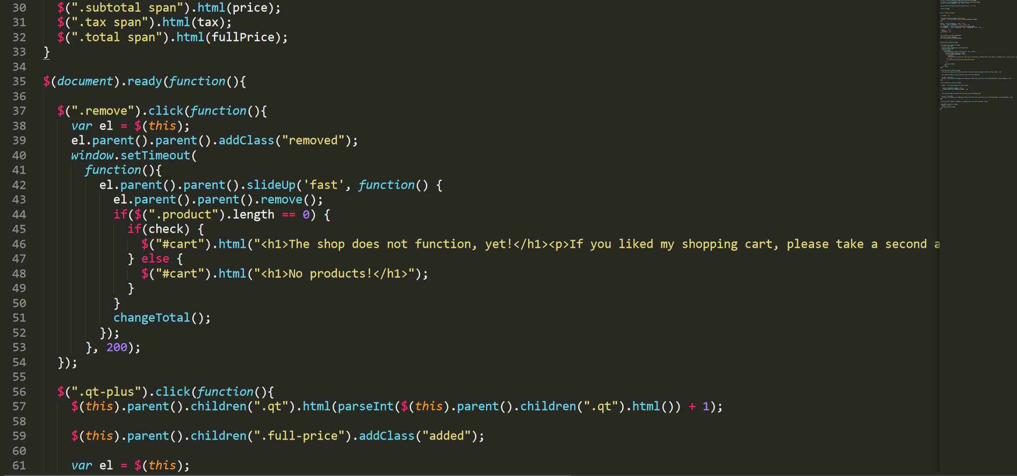

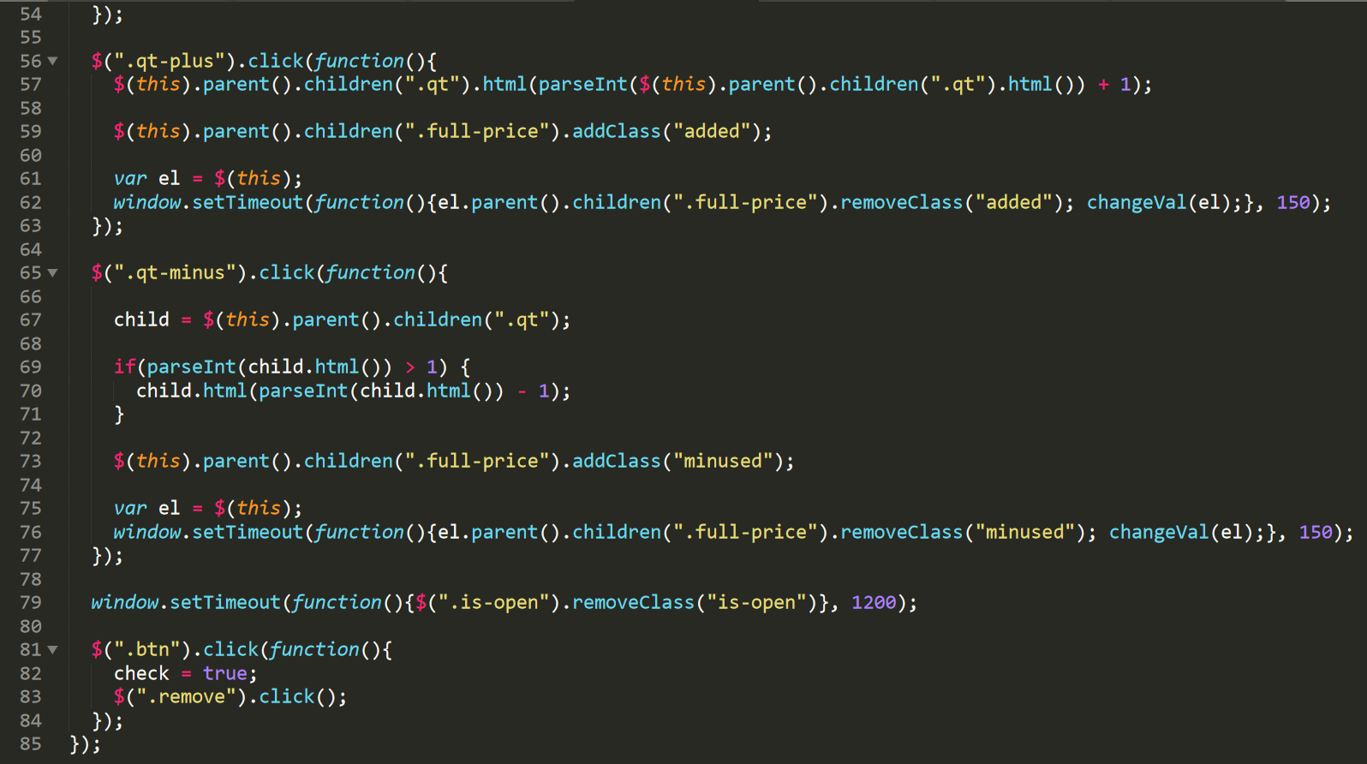





**Payment Page**

**Code: (index.html)**

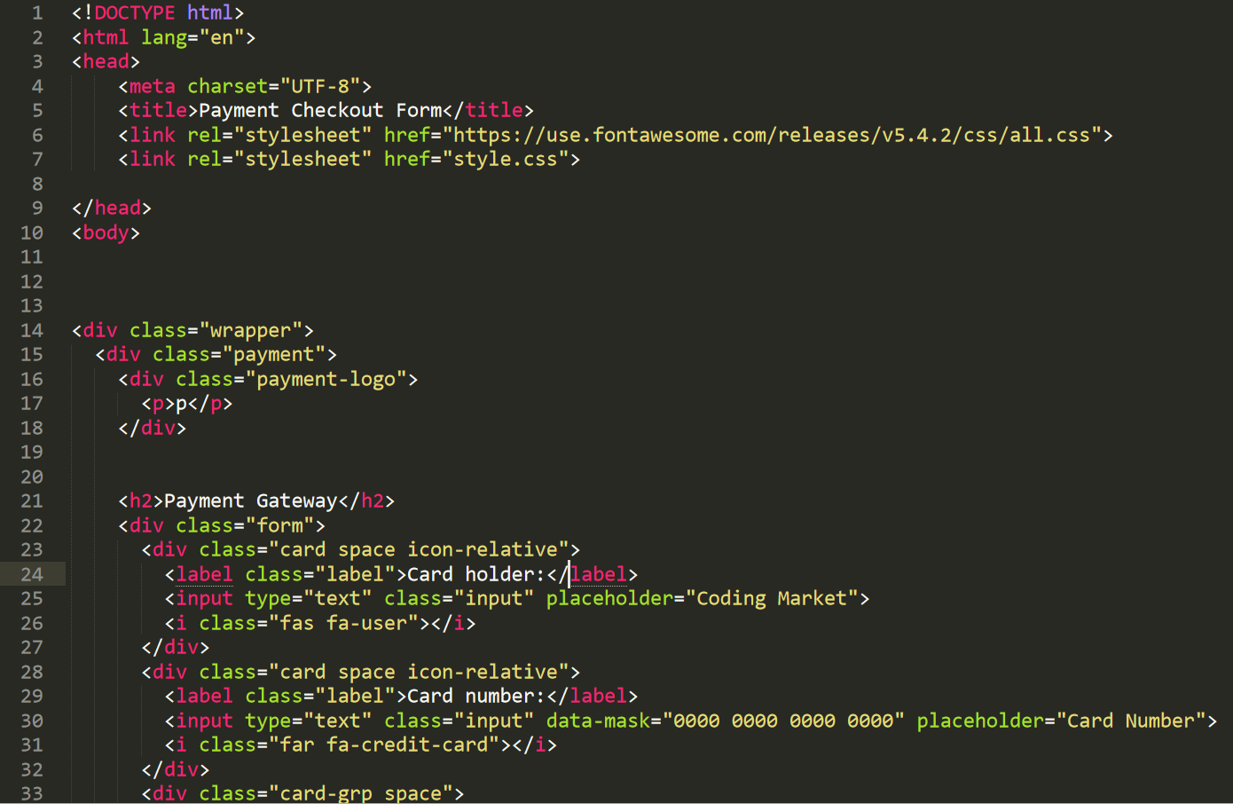

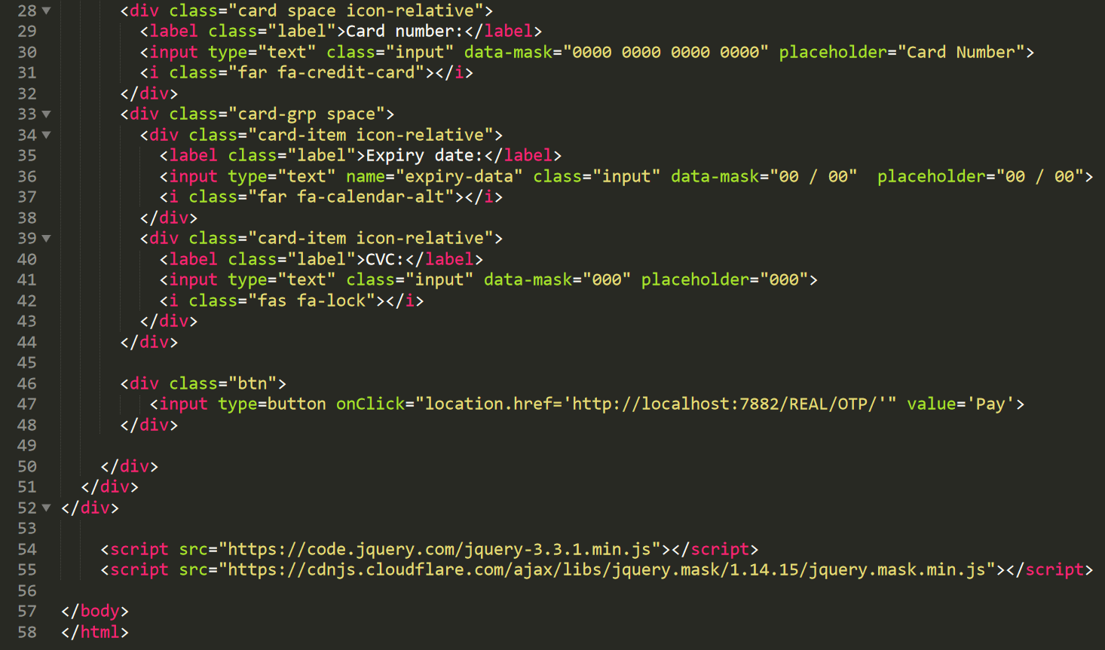

**Code:(style.css)**

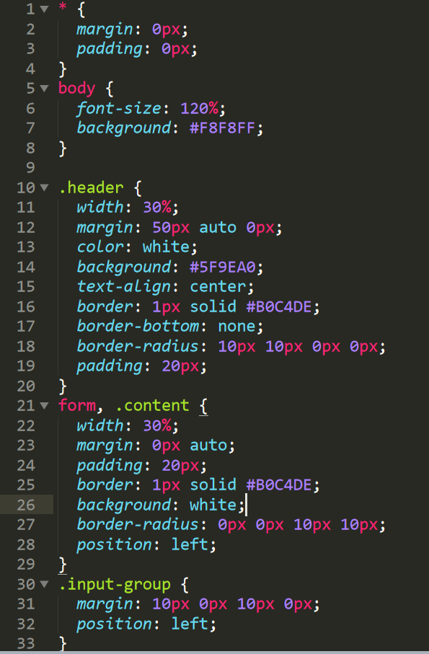

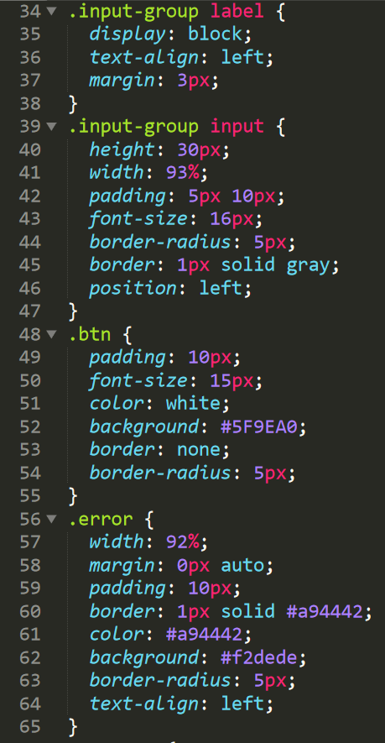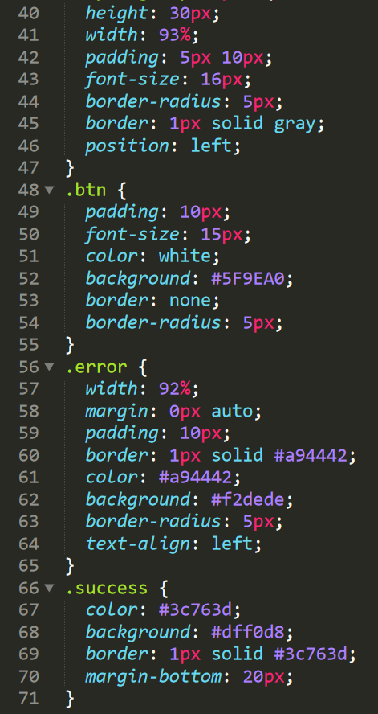



**OTP Validation**

**Codes: (demo.php)**

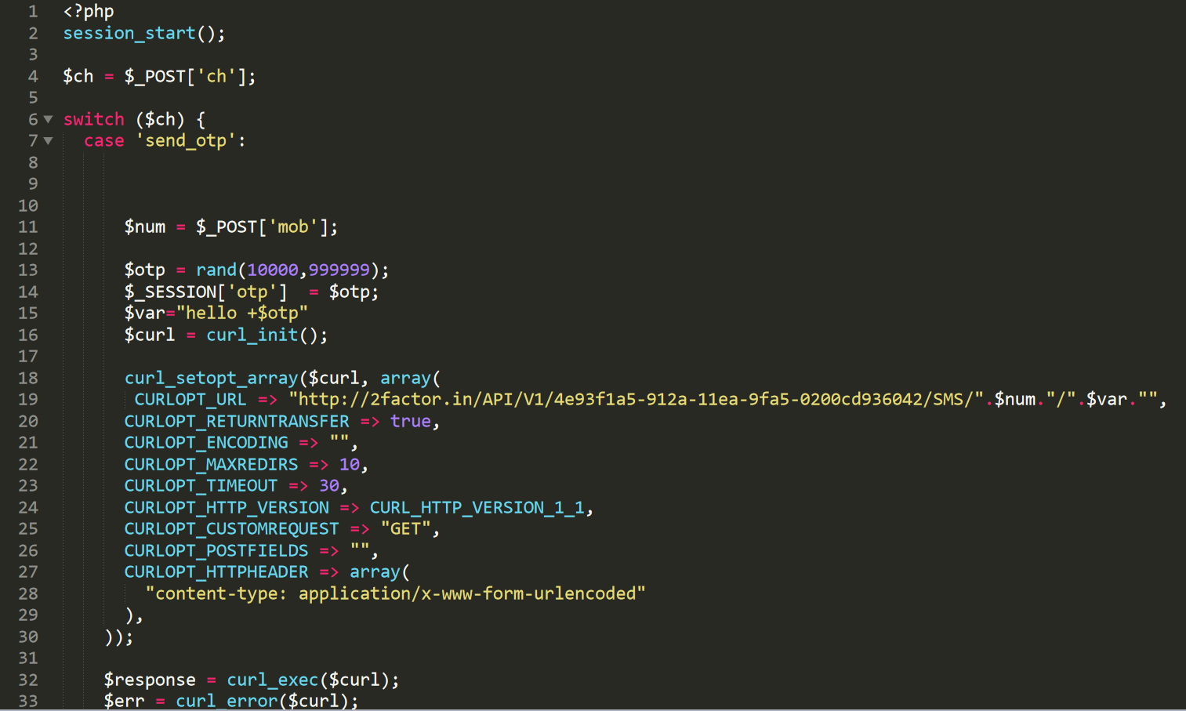

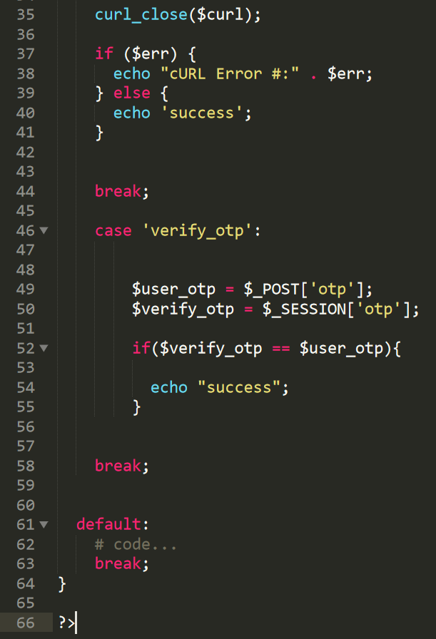

**Code:(index.php)**

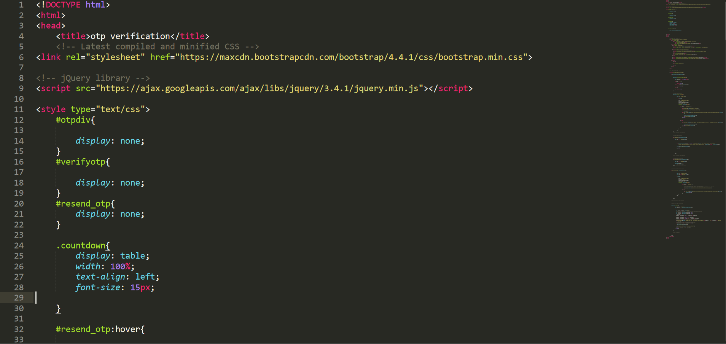

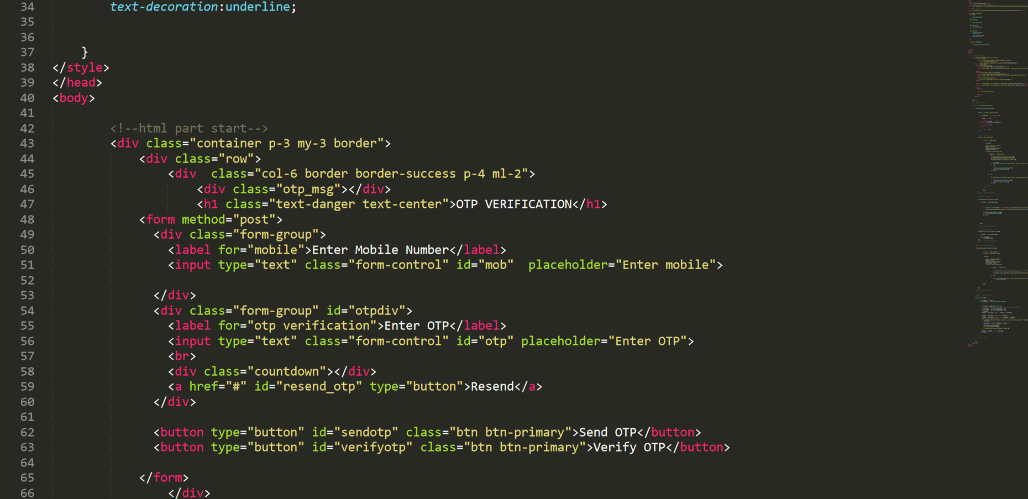

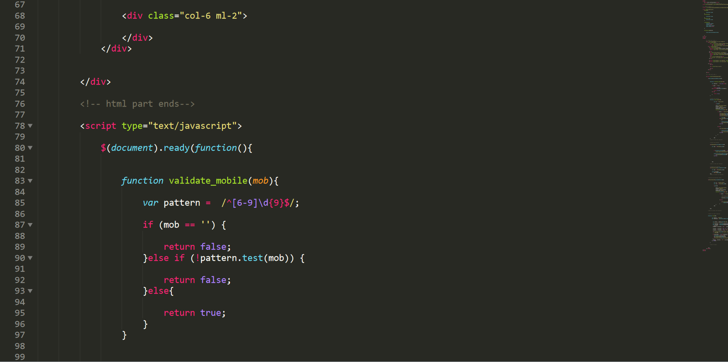

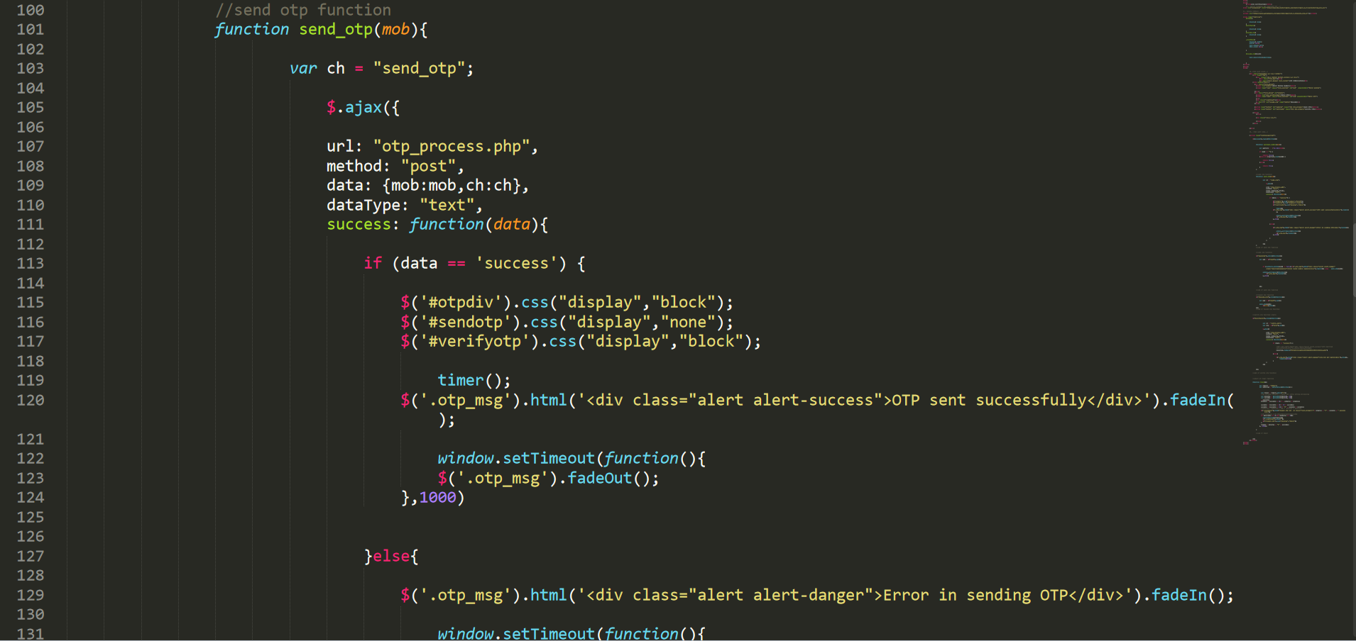

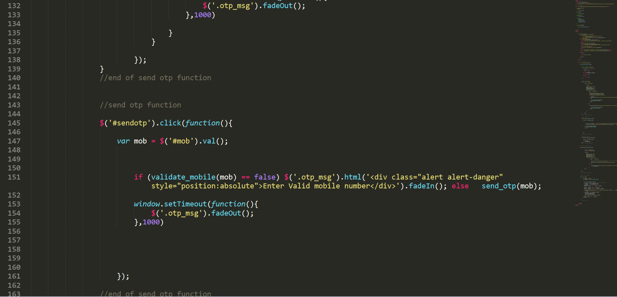

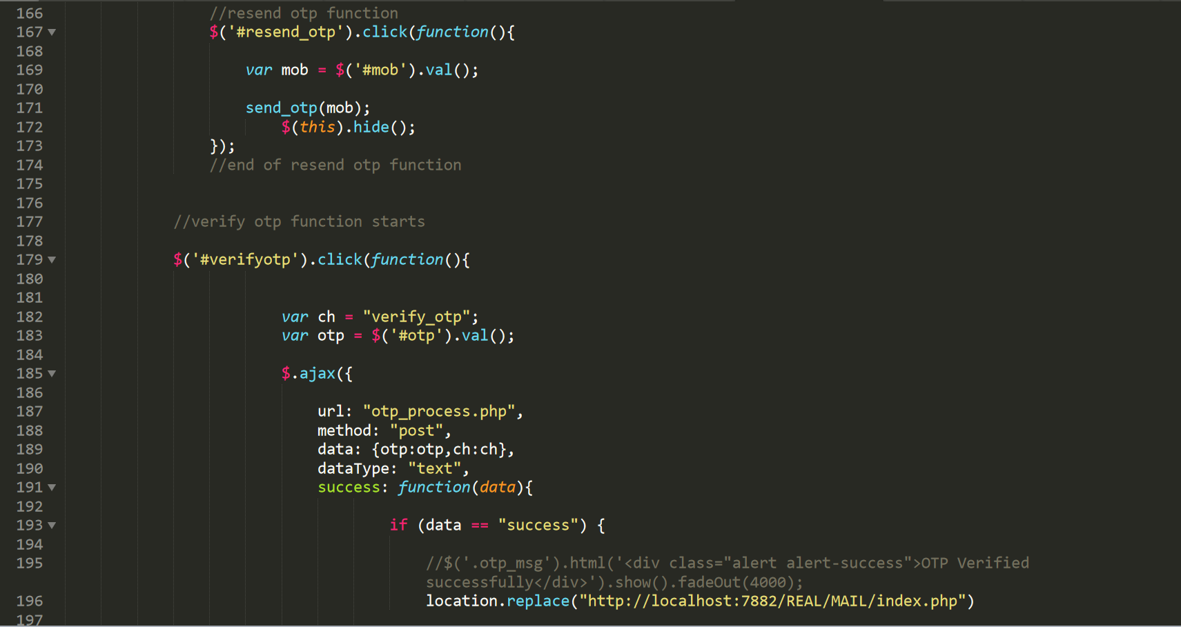

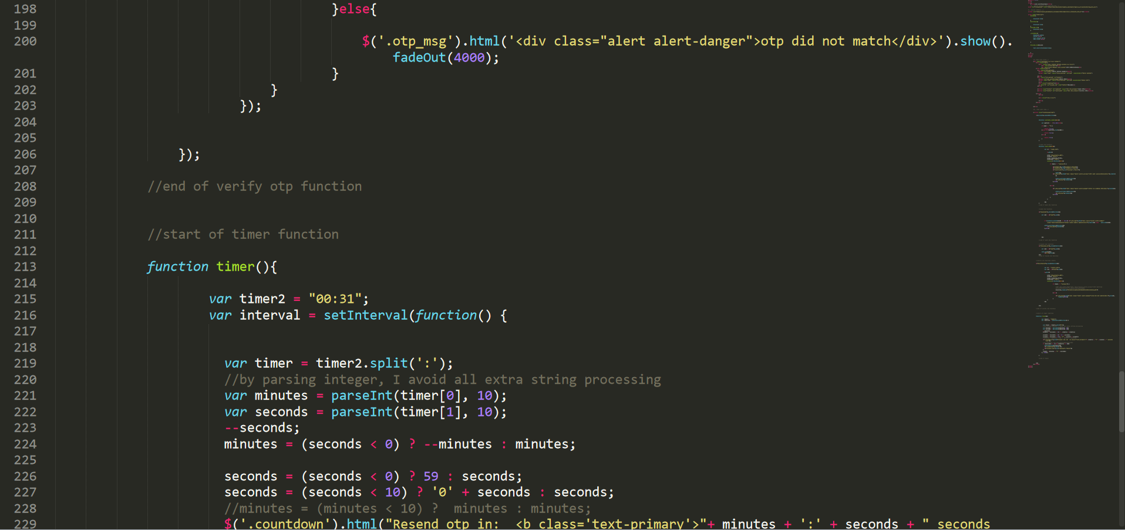

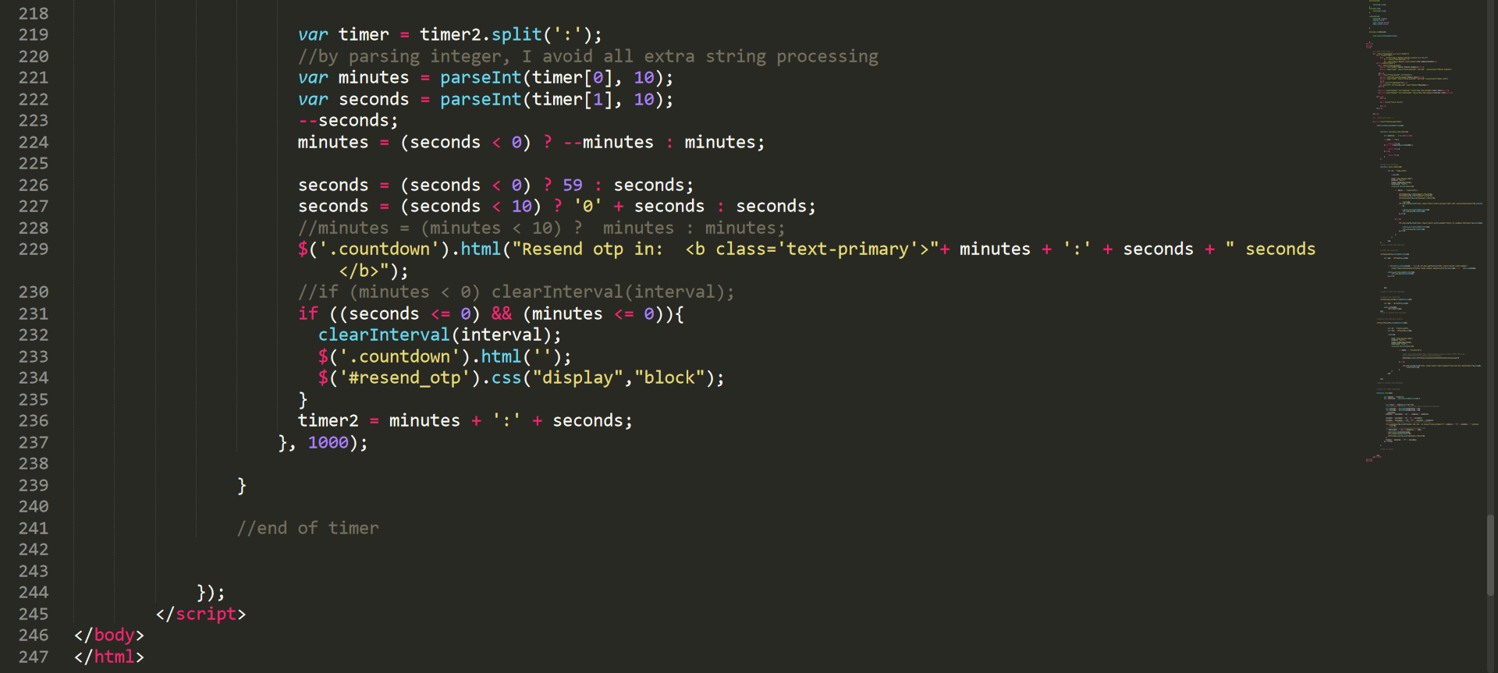

**Code: (otp_process.php)**

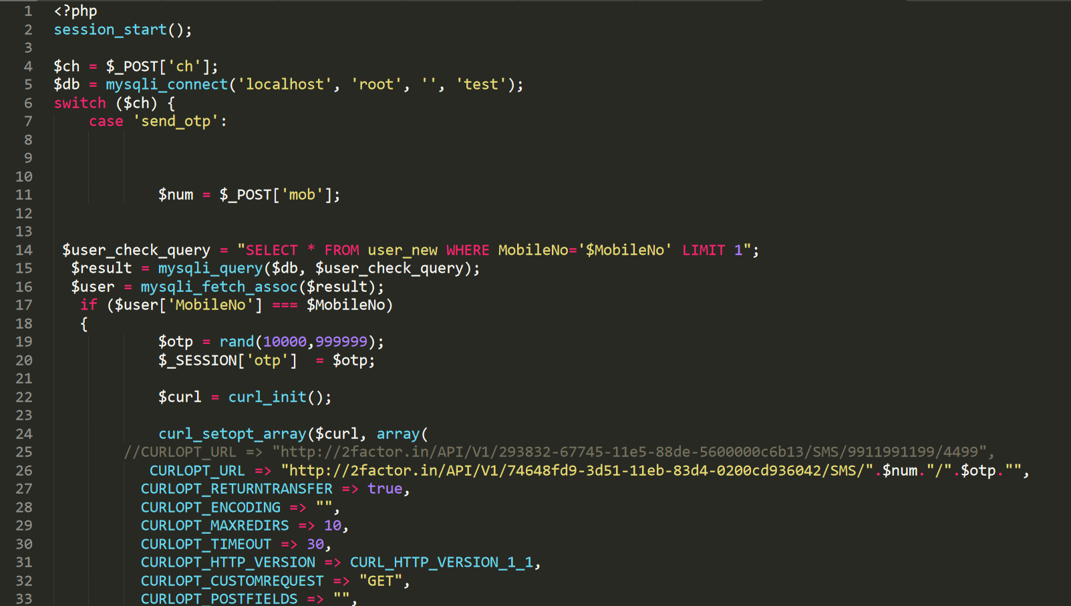

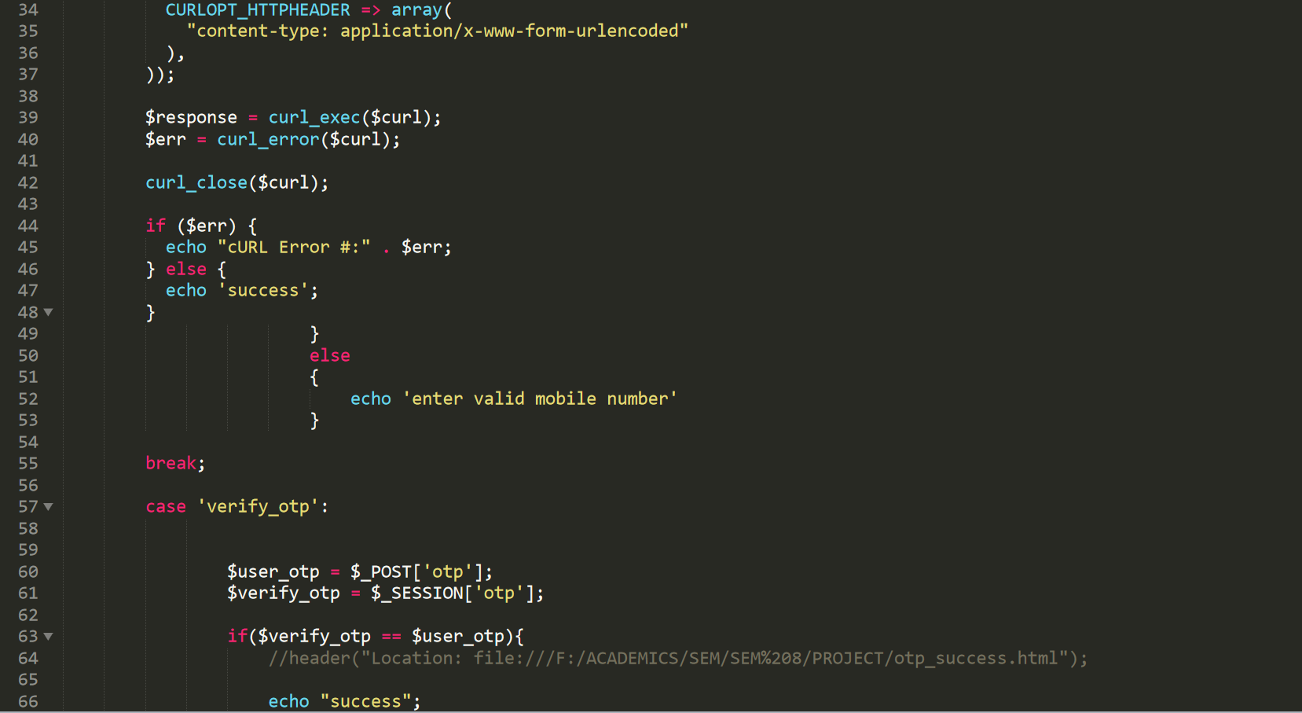

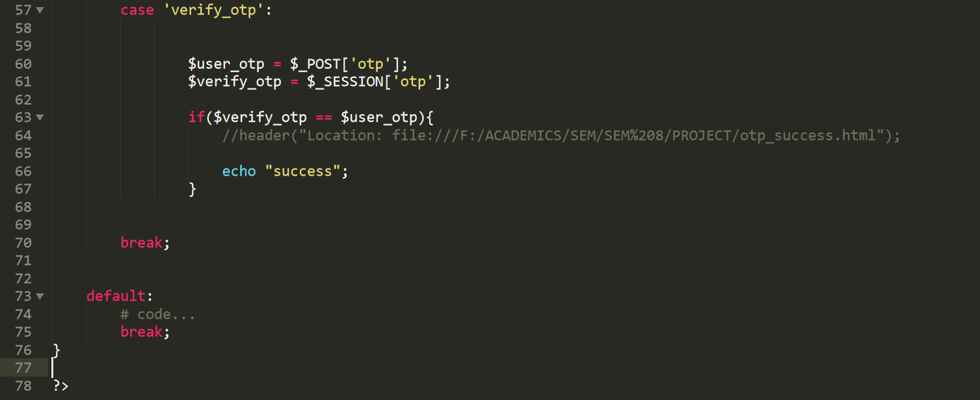

**Code: (otp.php)**

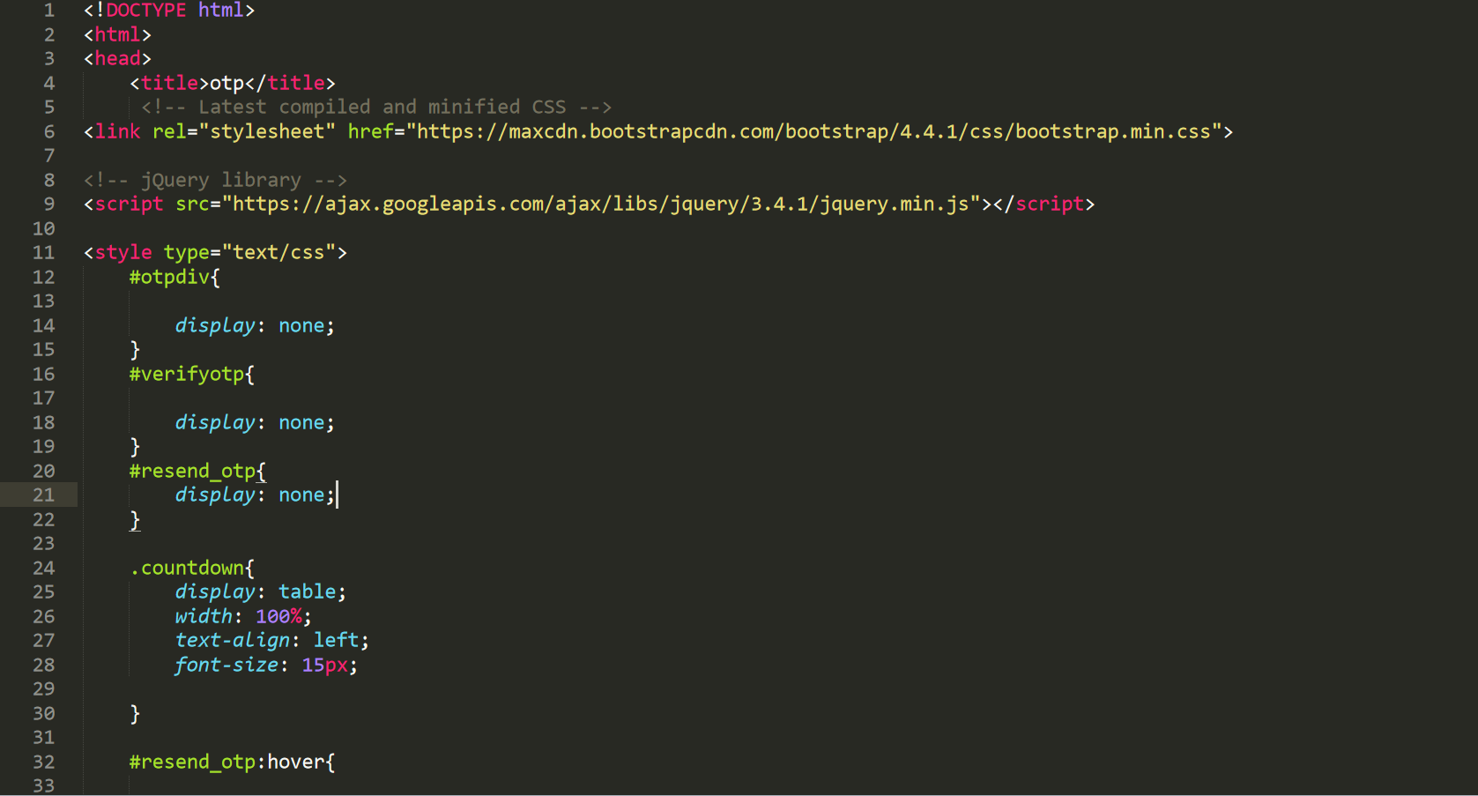

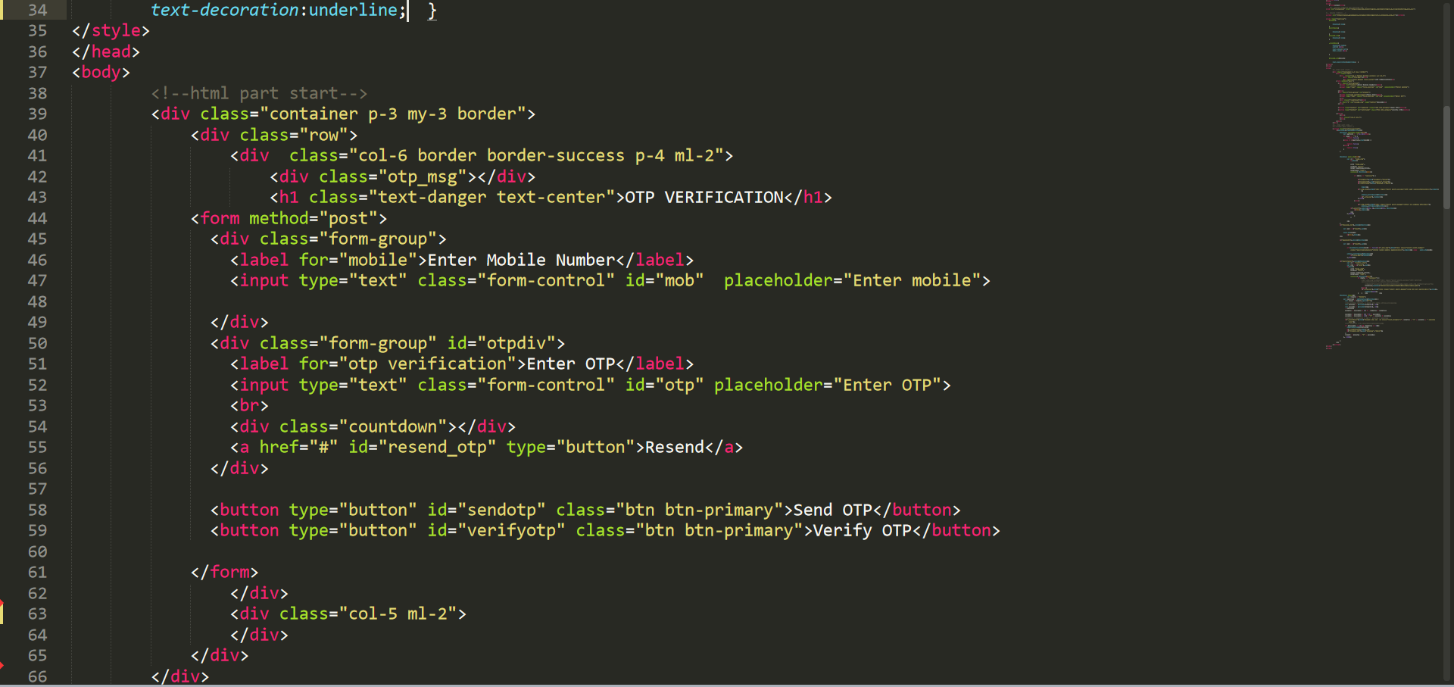

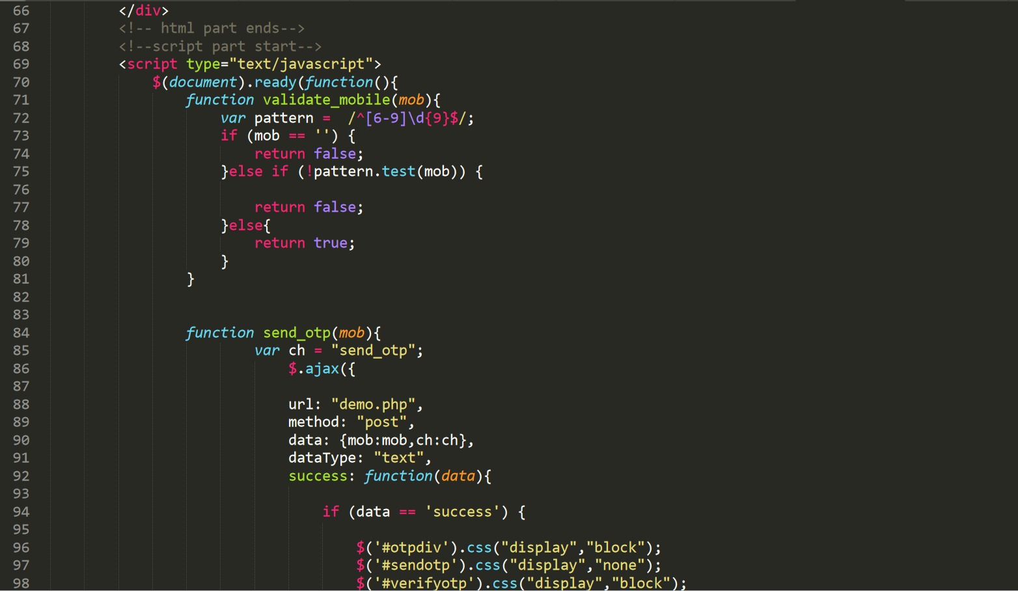

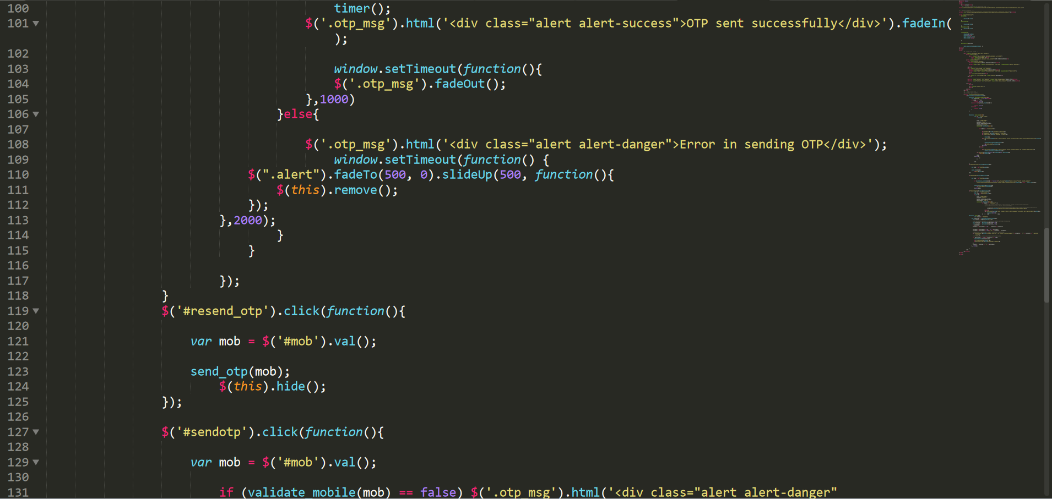

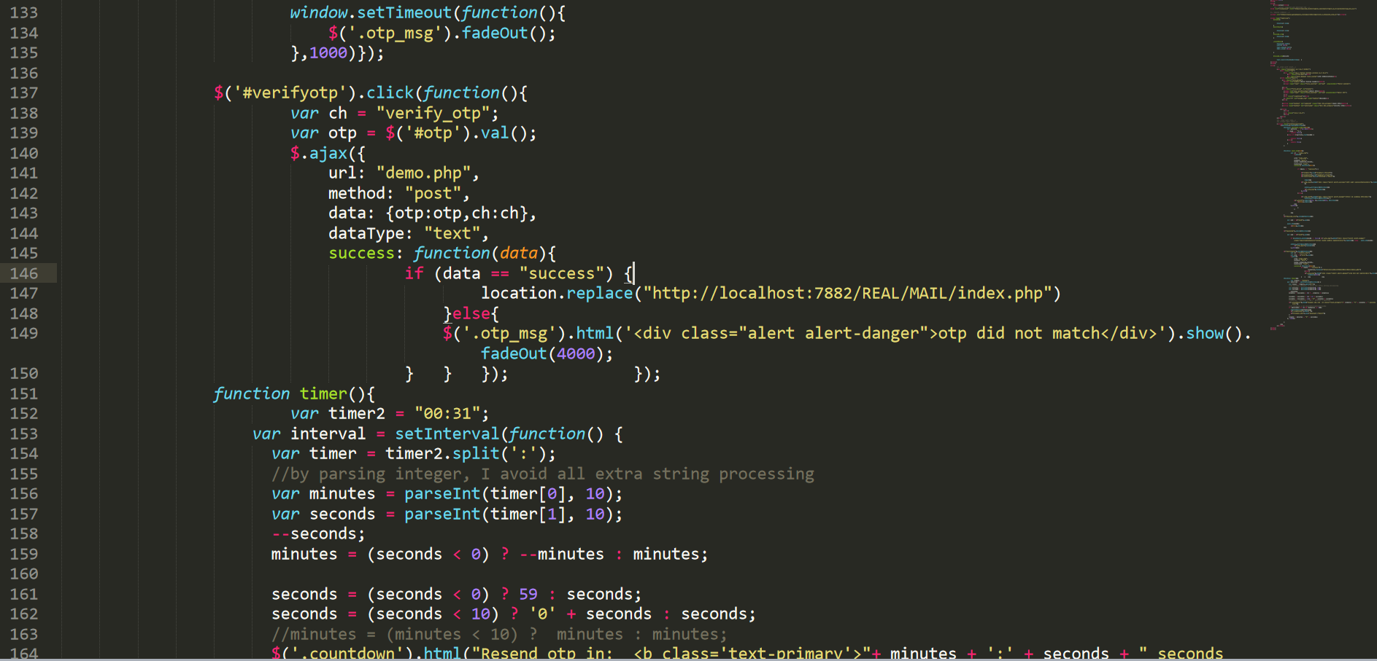

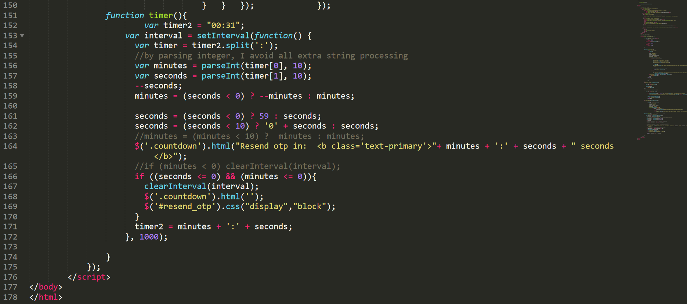







**Biometric Validation**

**(MAIL)**

**Code: (index.php)**

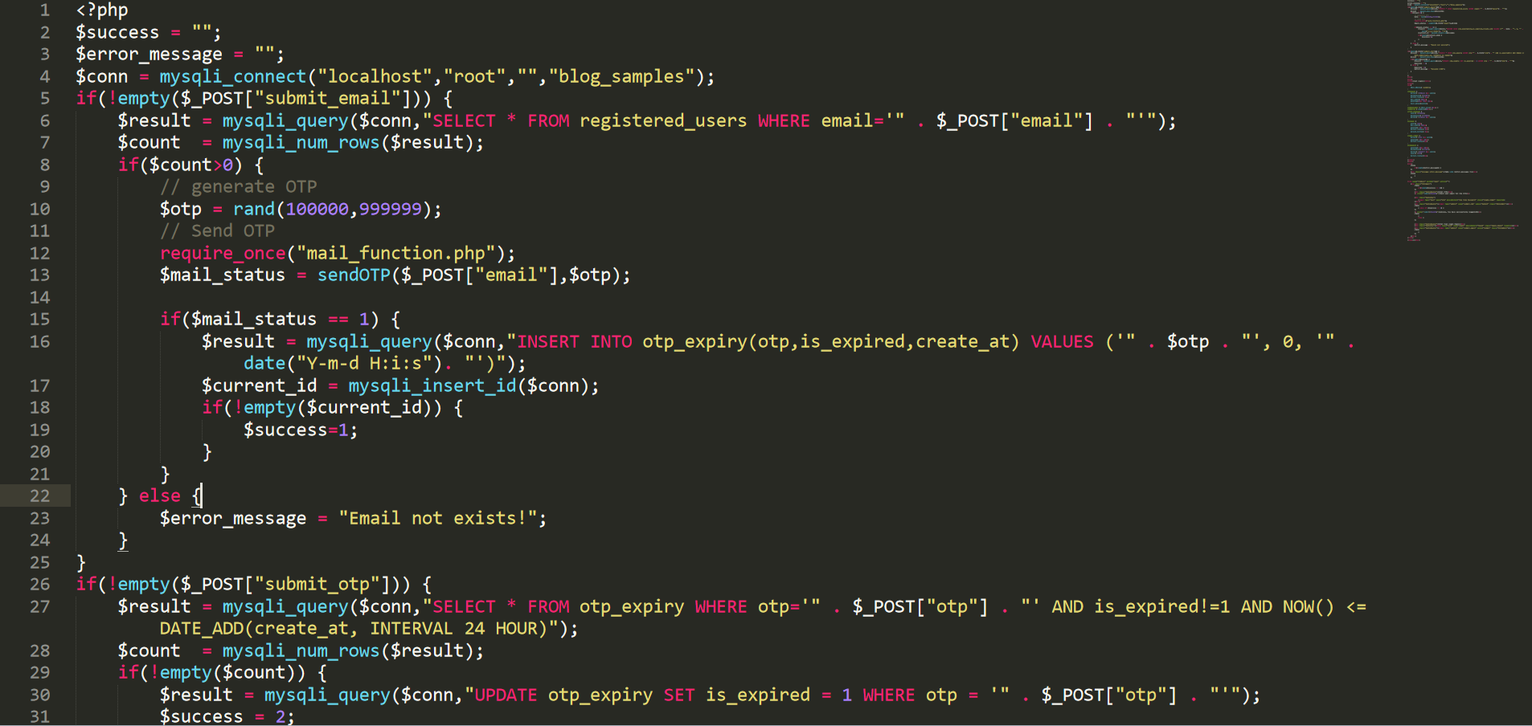

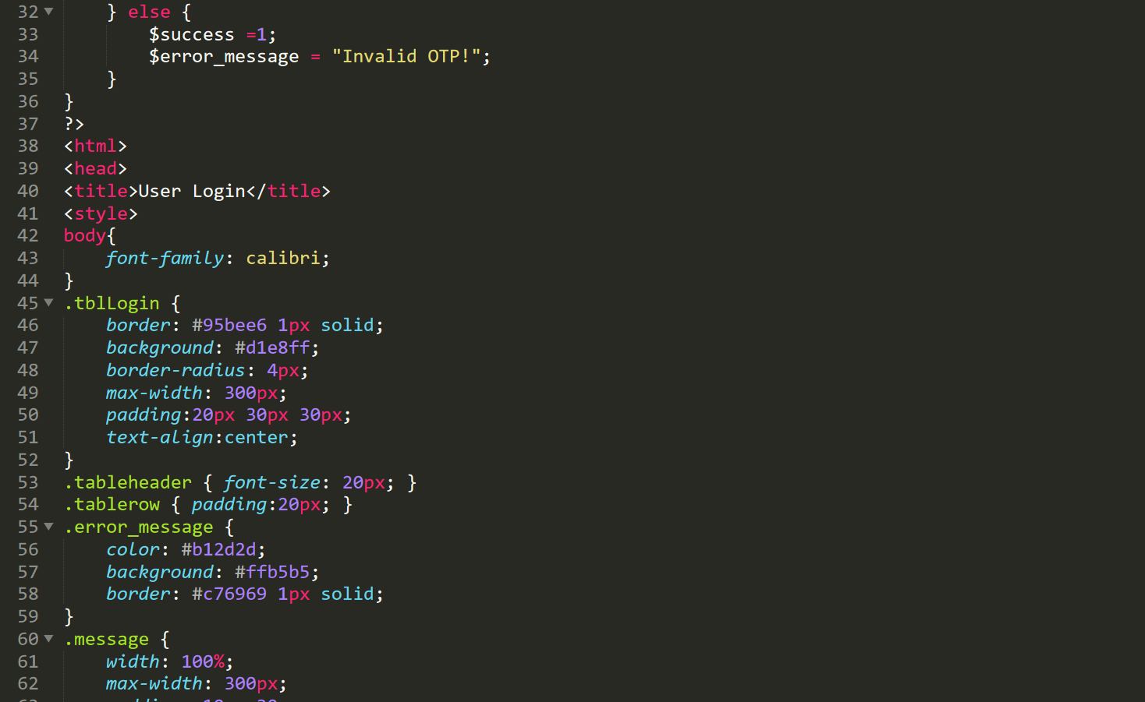

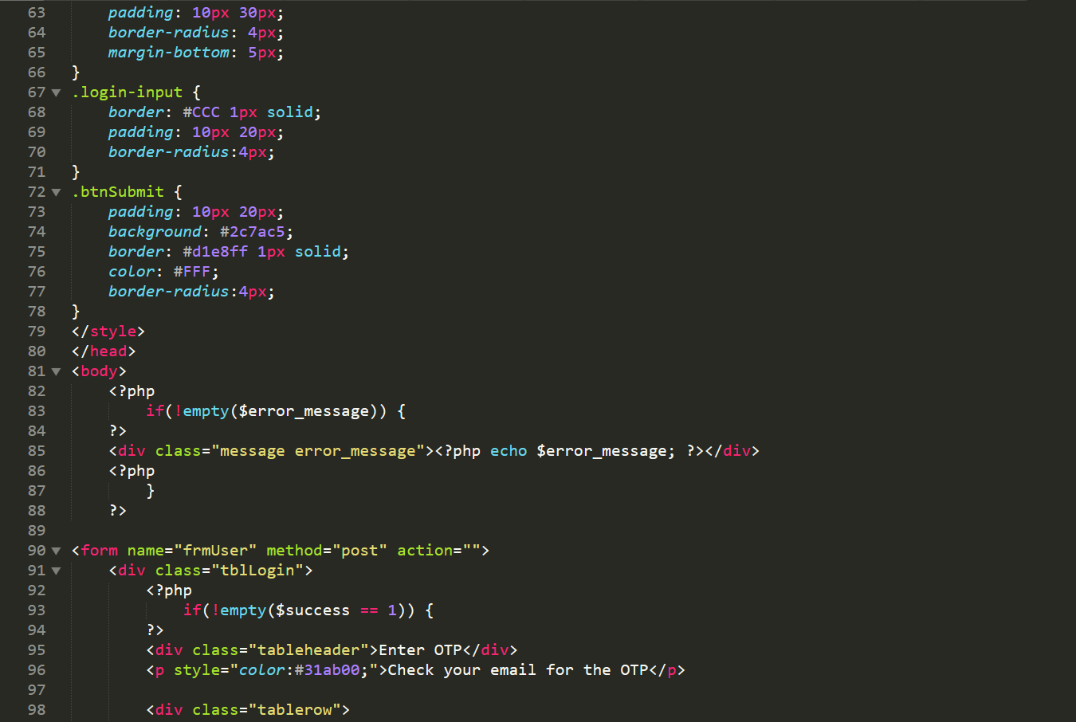

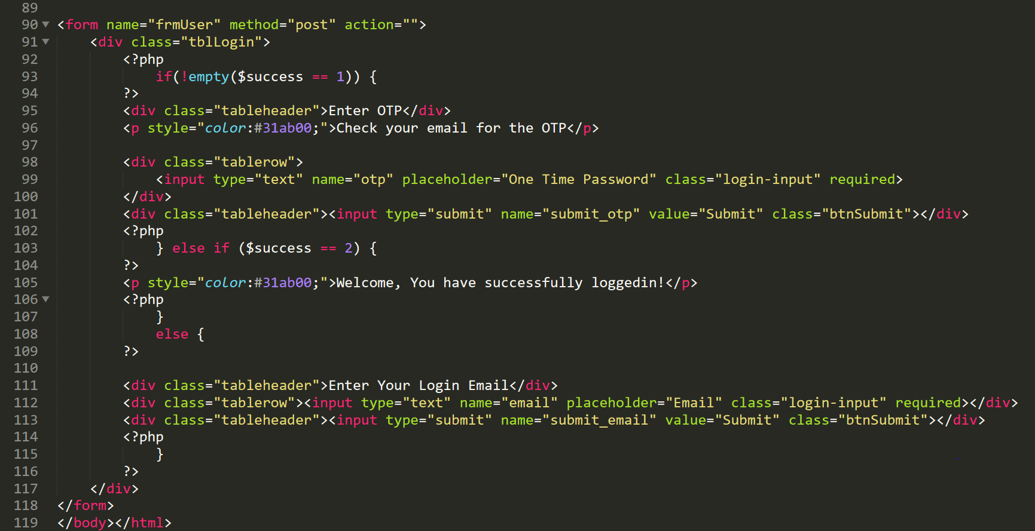

**Code: (Mail_function.php)**

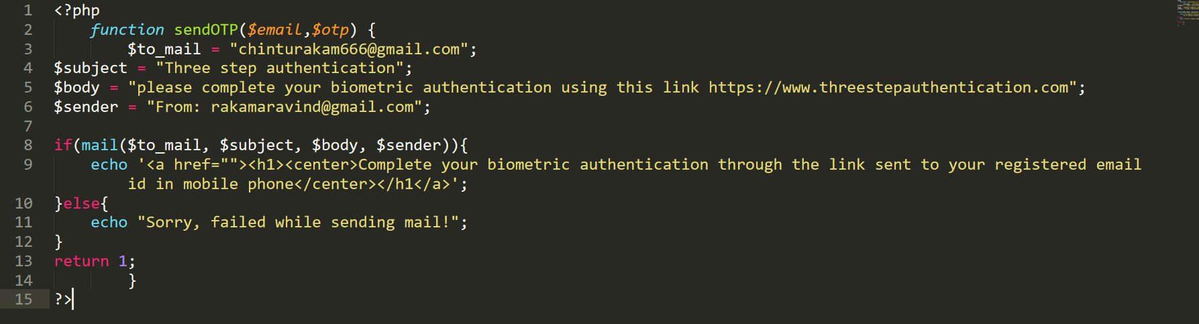

**Code: (server.php)**

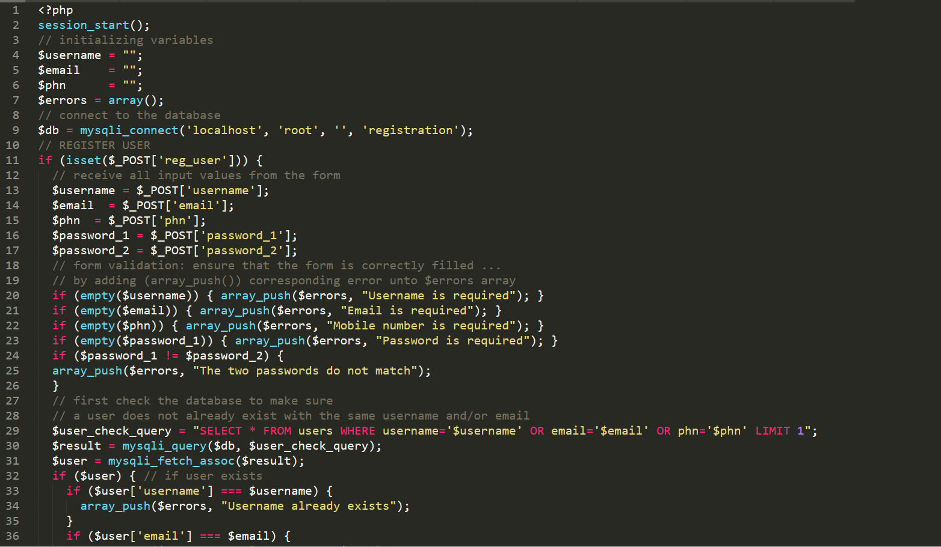

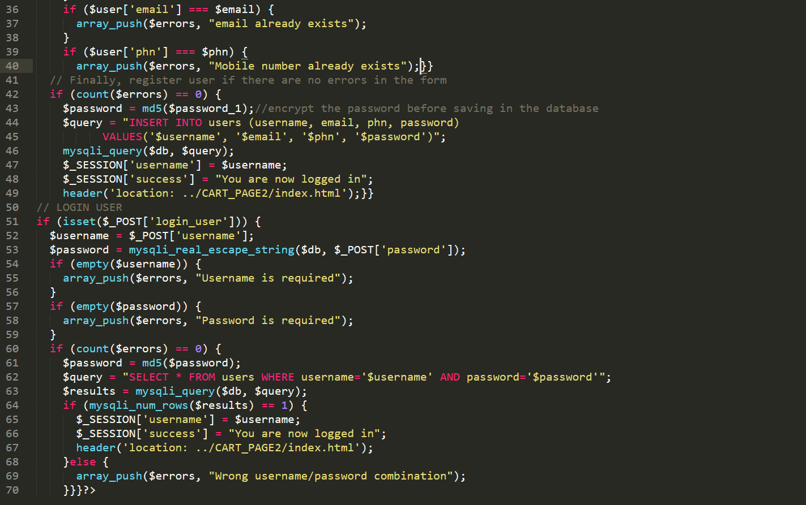

**Code: (errors.php)**

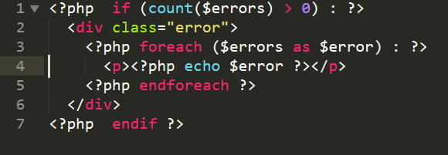

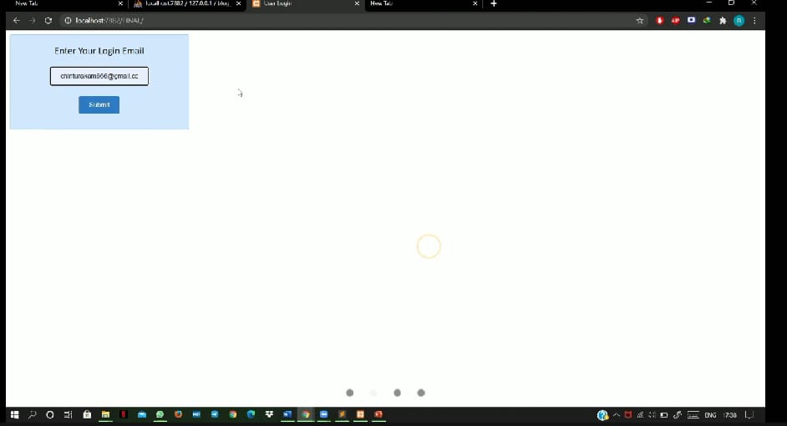

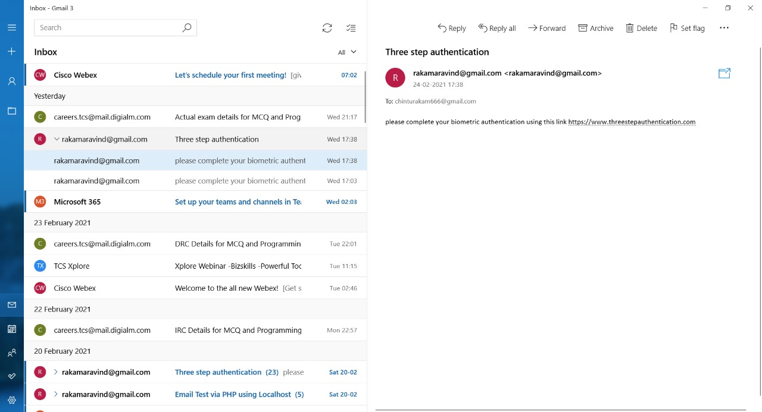

**Fingerprint iAuthentication**

**Fingerprint ihandler ijava icode:**





**Code: i(mainactivity.java)**



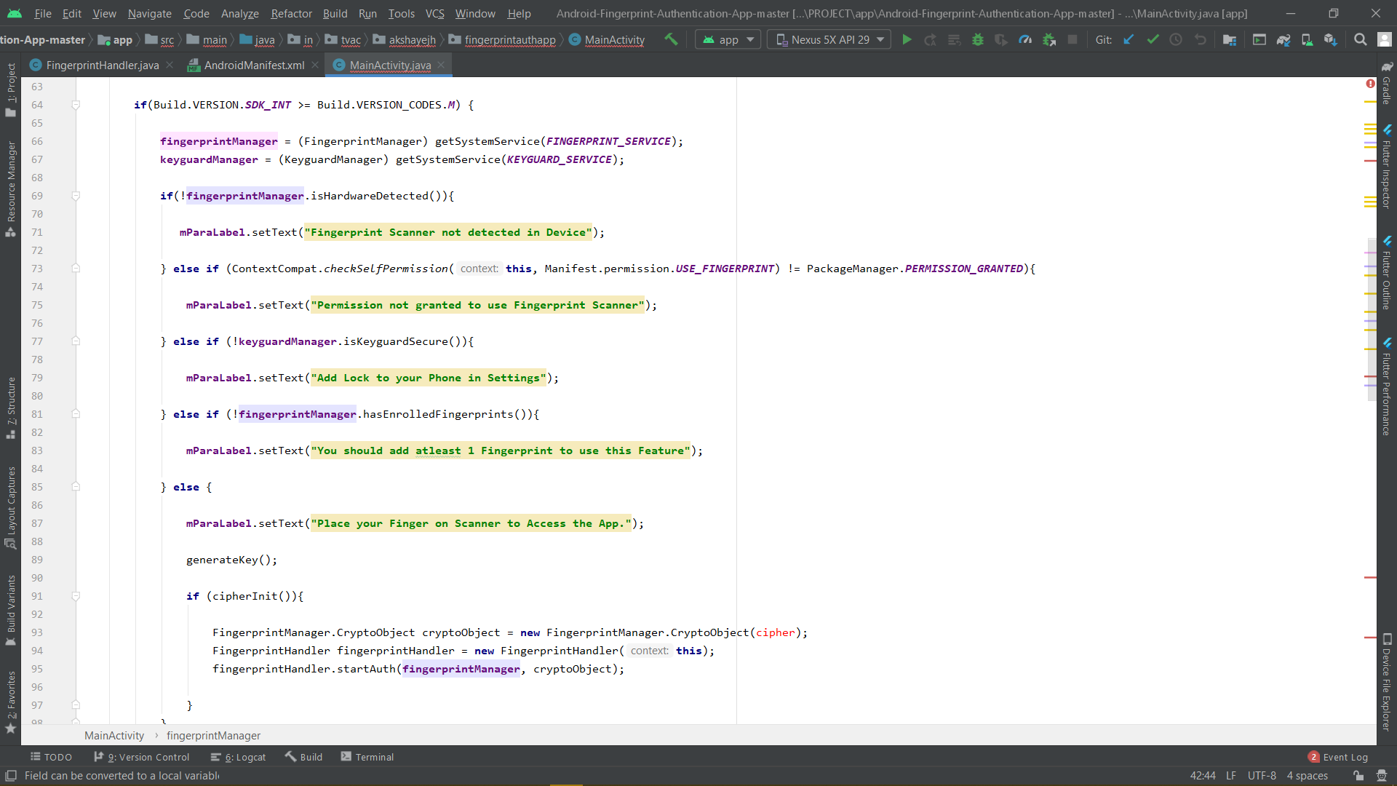



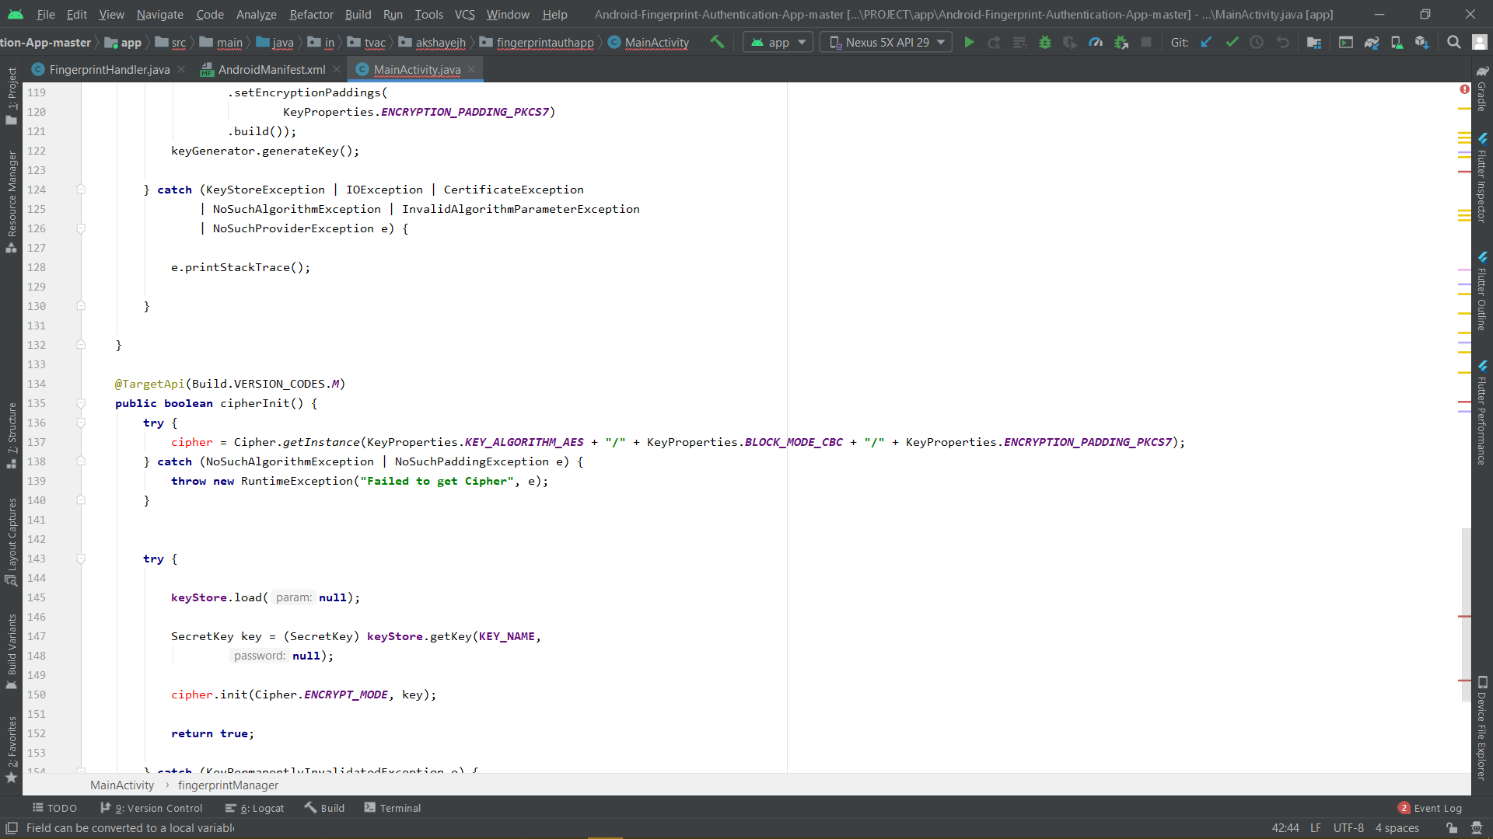

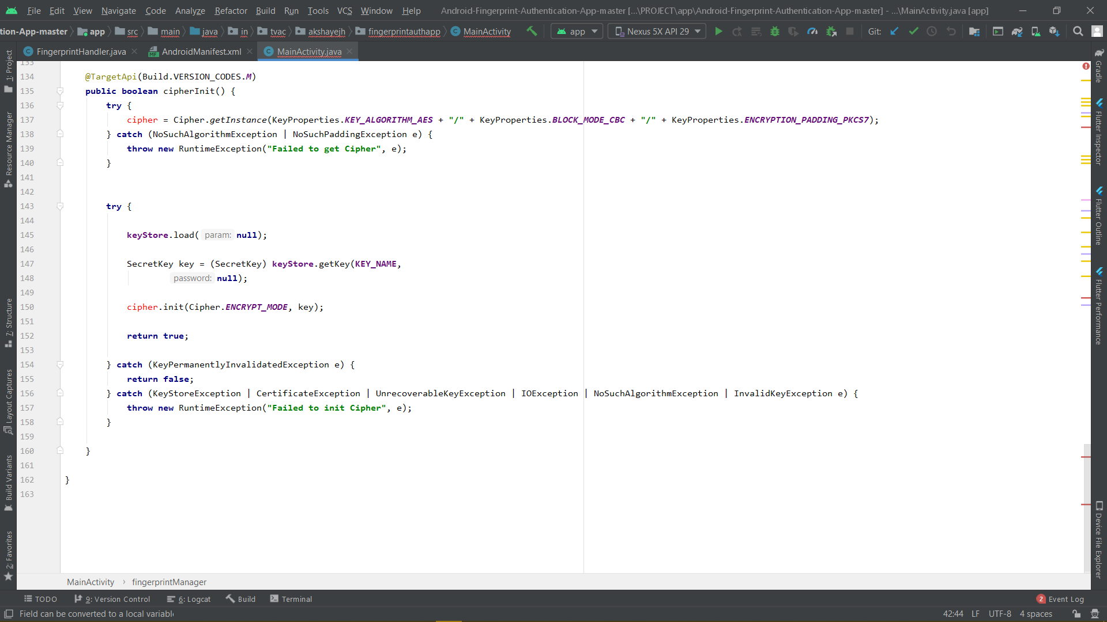

**Code: i(manifest.xml)**

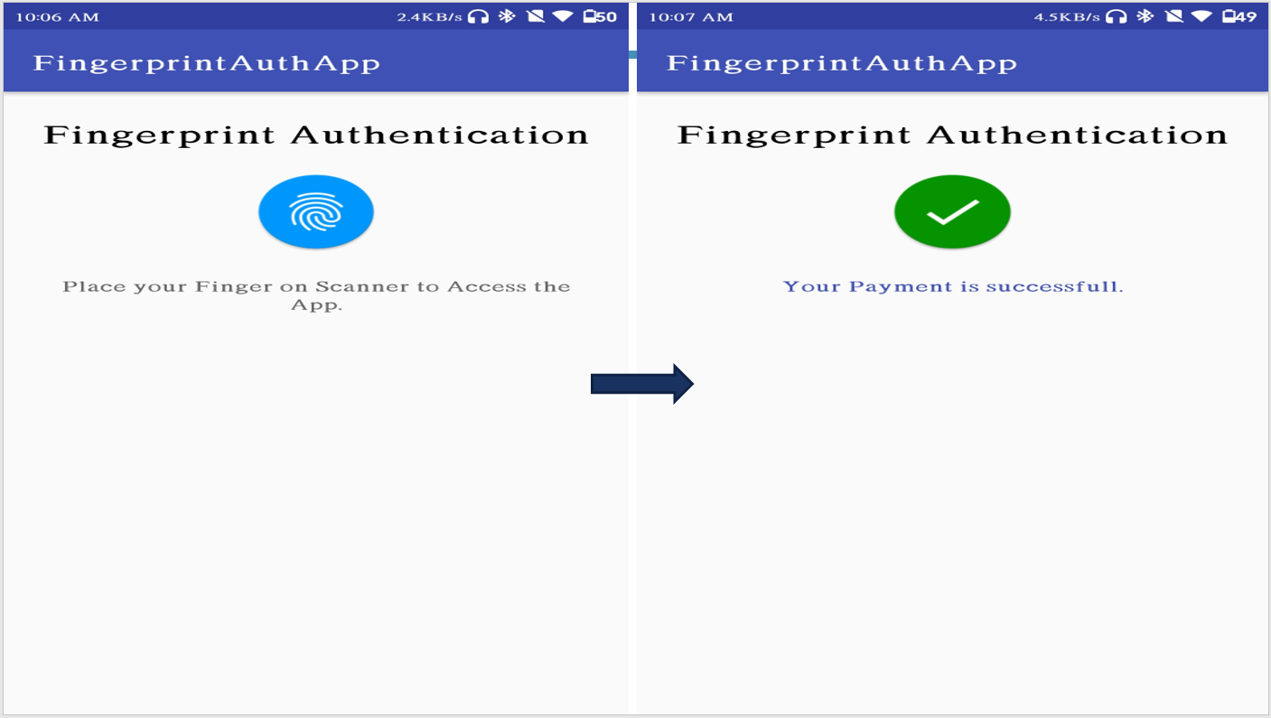

**CONCLUSION**

This iproject iprovides iauthentication iwhile iperforming ionline itransactions. iThere iare imany iways iof iauthentication ibut ifor ionline itransactions itwo-step iauthentication iis ifollowed, ithis iproject iensures iuser ithat ithe itransaction iis idone isuccessfully iusing ithree isteps iof iauthentication. iThis iproject ican ibe iimplemented iwhile iperforming iany ikind iof ionline itransactions ilike ionline ishopping, ionline itransfer iof ipayments, ietc. iOnly iafter iall ithe ithree isteps iare idone ithe itransaction iwill ibe icompleted.

**REFERENCES**

1. For iOTP igeneration:

i i i i i i i i i i i<https://2factor.in/CP/menu.php>

1. For idesigning iweb ipages:  
   HTML, iPHP, iCSS, iJS, iXML: i<https://www.w3schools.com/>
2. For ibackend iconnectivity: i

Xampp iserver: i<https://www.apachefriends.org/index.html>

1. For ifingerprint iauthentication iapp:

Android iStudio: i<https://developer.android.com/studio?gclid=CjwKCAjwnPOEBhA0EiwA609RecnMVmG4ENBFGOxJamANbDD81p2YsFTx4HGEE72MFFk_pBuRHin_FBoCmkAQAvD_BwE&gclsrc=aw.ds>

Flutter: i<https://flutter.dev/?gclid=CjwKCAjwnPOEBhA0EiwA609ReTL1ffWMj5OgMrAY6qp0CMyEz9vjWblGek0ksMXfVsDzc32mGcI6dRoCDQcQAvD_BwE&gclsrc=aw.ds>